A cross linguistic analysis of gender-neutral and gender-inclusive language
By
Taylor Roberts-Sampson
to
Linguistics at Columbia University

in partial fufillment of the requirements for the major in Linguistics
Columbia College
May, 2020

Table of contents
Introduction…………………………………………………………………....………...5
- The closed-class phenomenon………...…………………………………………………7
- Who can change a language? …………………………………………………………...8
Chapter 1: An overview of nonbinary forms……………………….......10
  - English…………………………………………………………………………………...10
1.1.A Overview of binary forms………………………………………………………….10
1.1.B They………………………………………………………………………………..11
1.1.C Neologisms…………………….………………………………………………......14
  - Spanish…………………………………………………………….…………………….16
1.2.A Overview of binary forms……………………………………………………….....16
1.2.B Gender-neutral alternatives: -x, -@, and -e……………………………………….17
1.2.C Public reactions…….……………………………………………………………...19
1.2.D La Real Academia Española (RAE) ………………………………………………22
  - French…………………………………………………………….………………….….23
1.3.A Overview of binary forms…………………………………………………….……24
1.3.B Gender-neutral alternatives……………………………………………………….25
1.3.C The Académie Franrçaise…………………………………………………………29
  - Hebrew…………………………………………………………………………………..30
1.4.A Overview of binary forms………………………………………………………….30
1.4.B Nonbinary Hebrew Project and other alternatives………………………………..32
1.4.C The Academy of Hebrew Language……………………………………………….39
1.5 Conclusion………………………………………………………………………………39
Chapter 2: survey and analysis………………………………………………..41
  - English………………………………………………………………………………….42
2.1.A Demographics……………………………………………………………………...42
2.1.B Isolated Identification…………………………………………………………...…43
2.1.C Sentence Ratings…………………...…………………………………………..….46
2.1.D Summary of findings……………………………..………………………………..50
  - Spanish…………………………………………………………………………………50
2.2.A Demographics……………………………………………………………………..50
2.2.B Isolated Identification…………………………………………………...………..52
2.2.C Sentence Ratings…………………...……………………………………………..55
2.2.D Summary of findings………………………………..………………………...…..59
  - French……………………………………………………………..……………………59
2.3.A Demographics………………………………………………………………….....59
2.3.B Isolated Identification………………………………………………………...…..60
2.3.C Sentence Ratings………………..………………………………………………...62
2.3.D Summary of findings…………………..………………………………………….65
  - Hebrew…………………………………………………………………………………65
2.4.A Demographics…………………………………………………………………....65
2.4.B Isolated Identification…………………………………………………..………..67
2.4.C Sentence Ratings……………...………………………………………..………...69
2.4.D Summary of findings……………………….……………………………………..71
  - Multivariable analysis…………………………………………………………………71
2.5.A Age and recognition…………………..……………………………………...…...72
2.5.B Language ability and recognition………………………………………………..74
2.5.C Identity and recognition…………..……………………………..……………….75
Conclusion………………………………………………………………………………...78
Appendices………………………………………………………………………………….82
- English survey……………………………………………………………………..……82
- Spanish survey……………………………………………………………………...…...84
- French survey……………………………………………………...................................86
- Hebrew survey……………………………………………………..................................88
References………………………………………………………………………………….90

introduction
There are two types of gender in the world’s language: grammatical gender and natural gender. The former refers to the assignment of gender, either male, female, or in some languages neuter, to inanimate objects. Not all languages have grammatical gender. In French and Spanish the tables are feminine (la table, la mesa). It is easy to envision crafting some pattern to account for this, perhaps that tables are linked to domesticity which is, for better or for worse, associated with women. In German, table is neutral der tisch. Maybe the Germans are more progressive. These sorts of generalizations, however, become tiresome quiet quickly and even the avid sophist will throw their pen when they realize table is masculine in Hebrew (שולחן), and Italian (il tavolo). Tracing any word through the web of the world’s grammatical gender languages will yield similar confusion. It is for this reason that linguists agree grammatical gender is an arbitrary classification system, relying in no part on some innate gender of the object, but rather solely on the inner working of each respective language.
Regardless of grammatical gender, all languages have natural gender. Natural gender refers to the gender identity of animate speech participants and referents. Natural gender is in many ways the antithesis of grammatical gender‚— it relies fully on the innate qualities or feelings of the referent. Natural gender language is flexible. While you can’t find a masculine table in Spanish (el mesa), you can find both female and male doctors (la doctora, el doctor). Thus, the same lexeme can often shift to accommodate natural gender.
In languages like English, Spanish, and French, pronouns are the primary space where the natural gender of the human referent is specified. Spanish and French go a step further as they require that this natural gender follow the same agreement rules as the grammatical gender of the language, meaning adjectives and adverbs must match the natural gender of the referent. To state ‘The girl is kind and beautiful’ in French (La ragazza è bella e gentile), one must match the adjectives ‘kind’ and ‘beautiful’ as well as the determiner ‘the’ to the feminine gender of the girl. Failure to appropriately craft gender accord makes a nonnative speaker stand out like a sore thumb. Hebrew also requires natural gender specificity in its verbal morphemes in addition to pronouns and adjectives.
Natural gender options rest primarily on the notion of a gender binary: speakers are either male or female depending on their assigned sex at birth. This binary to some extent can also account for some transgender individuals who identify as either male or female. Many people, however, do not identify within the binary; “popularly referred to as non-binary genders, genders that do not conform to socially accepted definitions of man and woman can completely reject established gender categories and norms, can mix characteristics of any number of genders, or can express gender fluidity” (Hord, 2016). Nonbinary speakers are left in a unique predicament: their language fails to account for or address their identity.
For all speakers, especially those whose identities already have a precarious status in mainstream society, language is a space of crucial affirmation. Hord writes, “Representation in language can be very important to one’s ability to have their identity understood by others and recognized in everyday speech interactions” (Hord 2016). In their essay “Stick Figures and Little Bits,” Finn Enke affirms the power of reference, ““conversations and references—by gendering or misgendering—have the power to affirm or refuse the ability of some persons to participate as speaking subjects and event to exist in language at all” (Enke 2016). Enke continues, arguing that the sign system itself reinforces the social enforcement of the gender binary: “we might well ask how deeply we intend to critique the gender binary if we can’t change the sign system as well” (Enke, 2016). As signifiers, “binary gender pronouns don’t just reflect binary gender, they create, teach, and enforce binary gender” (Enke, 2016). Some argue that in languages with grammatical gender, the issue of natural gender becomes more pronounced: “when everything from a pen to a table is gendered how can you be the one exception to a language’s entire structure” (Del Caño). The growing nonbinary or gender-movement is, thus, left with a challenging dilemma: How do they account for and create space for their identities within their language?
- The Closed-class Phenomenon
The discussion regarding pronouns and morphemes marking natural gender is closely related to the closed-class distinction. The closed-class phenomenon posits that some words, termed “function words,” “play a privileged role in syntactic processes…the claim is that such words are intrinsic to, identified with, or immanent in phrasal skeletons” (Bock, 1989). These “function words” reference categories such as pronouns, verbal morphology, and prepositions. Early theorists like Bock associate closed-class words with a difference in psycholinguistic processing, “special access suggests that the closed-class is retrieved from the mental lexicon by means that differ from those used for open-class words” (Bock, 1989). The privileged status of function words makes them much more resistant to change. This is evidenced also in the process of language contact in which pronouns, morphology, and prepositions are rarely borrowed or exchanged between languages.
While Bock ultimately rejects the association of prepositions as “inherent in the structural skeletons of sentences,” echoes of closed-class theory are pervasive in the analysis regarding the creation of gender-neutral language (Bock, 1989). In their study of epicene pronoun usage in the UK, Laura Paterson writes for instance, “Although pronominal change is not impossible, the closed-class status of the pronoun paradigm means that they are a firmly fixed set, and changes tend to be gradual, met with resistance and very slow and open to controversy” (Paterson, 2012). Linguist John McWhorter affirms this narrative in his 1998 book The Word on the Street, “around the world, languages are much more resistant to accepting new words, made up or foreign, which are as central to their grammar as pronouns are” (McWhorter, 1998). Paterson cites “the failure of epicene neologisms” as reason to further the closed-class theory: “it is simply not possible to force a new entity into this closed-class” (Paterson, 2012). Yet, both Paterson and McWhorter note exceptions to the rigidity of closed-class words. Paterson notes that “social change has affected the personal pronoun paradigm” despite its closed-class account. For instance, the Scandinavian invasion of Britain in which Old English borrows the pronouns theym and them from their conquerors.
- Who can change a language?
The discourse surrounding gender-neutral and gender-inclusive language is far from settled. Since Paterson’s work, more epicenes and ingenuities have surfaced as a rising social movement builds around the necessity to make room for nonbinary speakers. As my survey in Chapter 2 will confirm, English does appear to be at the forefront of gender-neutral innovation due its widely successful form of singular they. The success of English is also due to the lesser extent of which binary gender is integrated into English morphology—since English does not have grammatical gender, few changes must be made to accommodate nonbinary referents. This is not to say, however, that this movement stops with English. Gender-neutral and gender-inclusive language efforts cross the boundaries of language, finding a home in the conversations and debates of speakers across the globe. While most linguistic change occurs either gradually or due to some social force like invasion or colonization, the issue of gender-neutral language is quite unique as speakers intentionally craft and edit their own languages. This metalinguistic element is further enunciated by the very forms which they wish to change—closed-class elements which constitute the core of the language’s structure.
This paper will explore how nonbinary and gender-neutral movements have attempted to change language to accommodate themselves as referents in the languages of, English, Spanish, French, and Hebrew. The related gender-inclusive movements, which comment on the pluralization of nouns and conjugated verbs to include all genders rather than just use the unmarked male default, will also be analyzed. Both the gender-inclusive and the gender-neutral language movements require expanding the closed-class items of a language’s inventory to create room for speakers’ identities. Can speakers successfully alter the supposed core of their own languages? How does the unique circumstance of conscious language crafting affect this process of language change? And finally, to what degree are these gender-neutral and gender-inclusive language movements successful in the larger speech community?
The aim of this inquiry is twofold: to build a cross-linguistic data bank of gender-neutral and gender-inclusive language and to analyze to what degree these forms have been accepted by the mainstream speech community. Chapter One outlines the status of gendered options in each language, documenting and assessing different gender-neutral and gender-inclusive options. Chapter One also takes into account social opinion on the various forms and the reactions of formal institutions like language academies. Chapter Two outlines a survey created to measure the recognition and acceptance of these forms. The survey also tracks various demographic features like respondents’ identity regarding the LGBTQ+, age, and language ability in order to ascertain who is leading the propagation of these forms within the larger speech community.

Chapter 1: an overview of non-binary forms
Although closed-class words are resistant to change, interestingly, members of both the feminist and nonbinary community in each of the discussed languages continue to create and manipulate the forms of natural gender present in their languages. This chapter will outline the various morphemes, lexemes and other strategies put forth by speakers of English (§1), Spanish (§2), French (§3), and Hebrew (§4) to account for gender-neutral and gender-inclusive speech and writing. This chapter will, whenever possible, also cite the reactions of the general public and prescriptivist institutions on the proposed changes.
  - English
§1.1 provides an overview of the binary forms for pronouns and nouns within English that exhibit natural gender. §1.2 introduces they as a singular third person epicene pronoun and traces the history of the word and pronoun movement in the language. In §1.3, the issue of neologisms is taken up and it is concluded that singular they appears to be the most common option for non-binary pronouns in English and tends to be favored for its familiarity within the English language as an already used pronoun. The survey in the following chapter will attempt to gauge to what extent average speakers today consider and recognize they as a valid singular pronoun compared to other proposed third person singular neologisms.
1.1.A Overview of binary forms
The English language marks natural gender in third person singular pronouns as in Table (1.1) and nouns Table (1.2).
 | Subject | Object | Possessive | Reflexive
Masculine Singular | he | him | his | himself
Feminine Singular | she | her | hers | herself
Table 1.1
Masculine | Feminine | Neutral (if existent)
policeman | police woman | police officer
fireman | fire woman | firefighter
god | goddess
waiter | waitress
heir | heiress
poet | poetess
brother | sister | sibling
son | daughter | child
father | mother | parent
husband | wife | spouse
niece | nephew
Table 1.2
1.1.B They
In the past few years, it has become clear that singular they is at the forefront of potential gender-neutral pronouns in English. In 2019, Merriam-Webster declared they as the word of the year, affirming its usage as an epicene pronoun “for over 600 years” and noting “lookups for they increased by 313% in 2019” (Merriam-Webster 2019). The American dictionary also noted the prominence of they in politics and popular culture:
“Congresswoman Pramila Jayapal (WA) revealed in April…that her child is gender-nonconforming and uses they. Singer Sam Smith announced that they now prefer they and them and their third person personal pronouns. And the American Psychological Association’s ‘blog officially recommended that singular they be preferred in professional writing over ‘he or she’” (Merriam-Webster 2019).
In a study of two corpora of UK newspapers, Paterson finds that the “generic he,” popular in his 1961 data, has “fallen out of favour,” replaced by the overwhelmingly prominent singular they in his 2007-2008 samples (Paterson, 2012: 171). From his findings, Paterson proclaims it “appears as though singular they, despite arguments to the contrary is the (unofficial) English third person epicene pronoun” (172). The affirmation of organizations like Merriam-Webster in more recent years furthers Paterson’s demarcation of they as “unofficial” and begins the rise of institutional acceptance.
Additionally, singular they does not seem to affect speaker comprehension. In a 1997 study of reading time, Foertsch attempted to measure whether there was a difference between singular they and he cognitively. Previous studies found delays in reading when “the gender of the pronoun and the gender implied by the antecedent did not match” (Foertsch, 1997: 106). For instance, the sentence The doctor got her coat would have measurable delays around the pronoun where The doctor got his coat would not. Foertsch created sentences with singular they and binary pronouns and set out to measure if the delay persisted. He found singular they to be read more quickly than the cases with a dissonance between gender stereotype of the antecedent and the binary pronoun which followed (Foertsch, 1997: 106). Foertsch also found that singular they was read as quickly as the “gendered pronoun that matched the stereotype of the antecedent” (106). Foertsch’s study demonstrates that already in 1997 singular they “is a cognitively efficient substitute for generic he or she, particularly when the antecedent is nonreferential” (106).
While singular they is now endorsed by institutions like dictionaries, its history as an epicene pronoun within the English language is quite tenuous. As Dr. John McWhorter notes in his 1998 book The Word on the Street, even twenty years ago the position of they was under heated debate: “what we are often told is that the use of they, them, and their to refer to single persons is a mistake because they, them and there are plural words” (117). Long before the current issue of non-binary identity, these debates were framed around everyday English sentences like Each student must hand in their homework versus Each student must hand in his homework. The imposition on they as marking only the plural can be traced back to the early prescriptivist movement (Hord, 2016) starting in the 1500's with the blatant reasoning that he ought to be the singular form to align with the “natural order” of humanity in which “the worthier” male and his pronoun “is preferred and set before” (McWhorter, 1998: 118). In the 1700s when it was supposedly no longer socially appropriate to justify sexism in clear terms, the narrative shifted to a more technical excuse: he was always intended to be used in neutral and ambiguous singular cases (McWhorter, 1998: 118).
With the rise of feminism, came theories of inclusivity and the language to back it up; he or she was the respectful option for ambiguous singular cases; it was now clear that Each student should hand in his or her homework. McWhorter takes issue with this form, stating “the man is still first” and “it could never go beyond writing or formal speech” due to its awkwardness as a phrase (McWhorter, 1998: 119). He argues that he or she is unnecessary because English already has an epicene pronoun: they - why force the conscious, clunky, and “proper” form of he or she when they already bounces out of the mouths of English speakers daily (119). Though not a part of the academic dialogue at the time, he or she also does not account for cases where an individual person wishes to be identified outside of the gender binary; one could never say Olivia went to get his or her bags in the way that one could say Olivia went to get their bags.

1.1.C Neologisms
Luckily, the trend of he or she quickly fell out of favor and those who now wish to use epicene pronouns for themselves have an option. The story, however, does not end here. In addition to they, neologisms have flooded the language in attempt to account for the various ways people which to identify themselves. Figure 1.3 and 1.4 are the front and back of a pronoun card found on the University of Wisconsin, Milwaukee LGBT Resource Center’s website.
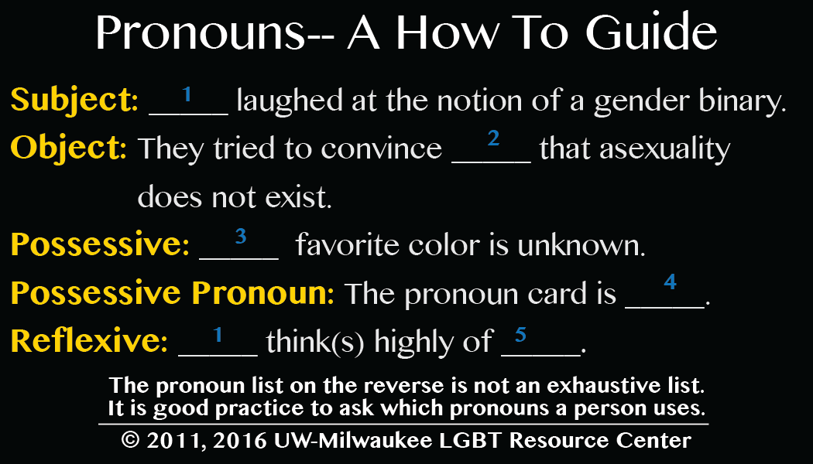
Figure 1.3 (Pronouns 2011, 2016)
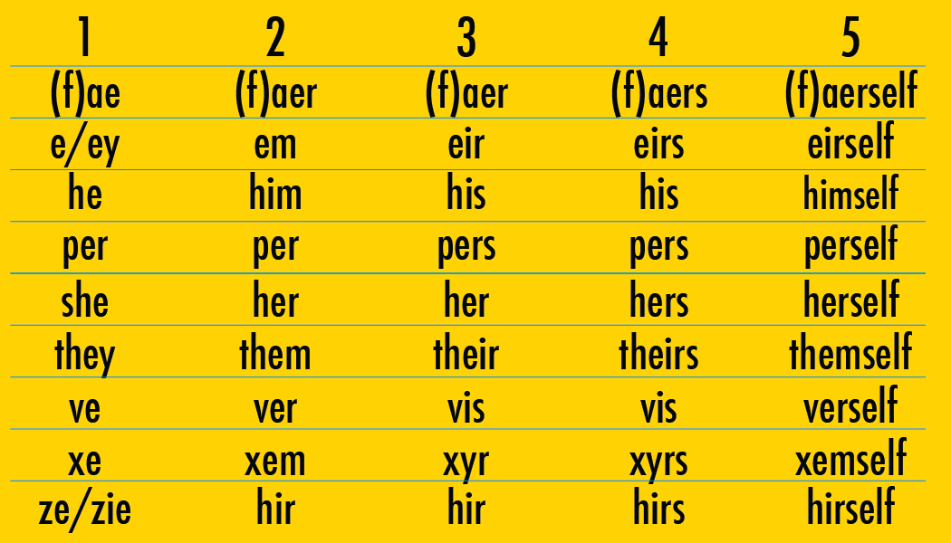
Figure 1.4 (Pronouns 2011, 2016)
Figure 1.3 educates readers on the various cases which a pronoun takes on in English and aligns these forms with the specific clitics in Figure 1.4. Alongside the familiar pronouns of he, she, and they, we are now presented with a slew of alternatives including f(ae), e/ey, per (which is already a preposition in English), ve, xe, ze/zie.
For average English speakers these forms likely appear alien and even if one were to recognize a form, it is incredibly unlikely that they would know how to correctly mark it for each case (subject, object, possessive, etc.). Pauline Park, a transwoman and activist, is skeptical that this reality will ever change. She asserts “that pronouns such as zie and hir will never achieve widespread use because they have no ‘integral connection to the language and culture into which [they] are introduced’” (Hord, 2016). The institution affirmation of singular they may also encourage nonbinary individuals to elect they over more obscure options. Lyft, a popular driving app, for instance, now allows passengers to choose their pronouns, offering they/them/theirs alongside the binary pronouns (Dickey 2019). For those who use a neologism from Figure 2.2, their options on Lyft include only “my pronoun isn’t listed” or “prefer not to say” (Dickey 2019). Following the acceptance of they is almost always this stipulation outlining the exclusion of epicene neologisms. The Associated Press Stylebook, for instance, “mandates that journalists not use other epicene pronouns such as ze/zim/zir for sake of clarity for readers unfamiliar with the politics of gender-neutrality” (Del Caño, 2019: 9).
Omission of the more obscure epicenes is pervasive within the LGBQ+ community as well. In a study to measure pronoun usage from within the queer and non-binary community, Hord finds “approximately 66% of all English survey respondents were using some form of gender-neutral pronoun” and “those using singular they made up the single largest group of pronoun users at 34% of all English respondents” (Hord 2016). Hord asserts, “the popularity of they, both on its own and in mixed groups, shows that it has already become something of a “standard” or default neutral pronoun in English speaking transgender communities, and is perhaps more easily understood outside of them because it is already a part of the language.” He also reasons that the small number of individuals using other epicene pronouns is likely due to the burden of having to explain these more estranged forms. This point is crucial for the case of English where the primary instances of natural gender labeling occur in the third person. Thus, it is not up to the non-binary individual who wishes to identify with ze/zim/zir to implement these forms, but rather it is dependent on speakers who reference zim in the third person to remember and produce the pronouns. The reality of referencing exists also in the realms of Spanish, French, and Hebrew discussed in the following sections, but the burden in those languages also falls on the speaker when using first person forms, adjectives, and nouns and on the speech partner in second person forms.
  - Spanish
§1.2.A provides an overview of the binary cases, pronouns, and determiners in Spanish. §1.2.B traces the three forms: -x, -@, and -e and finds to be a more viable case marker for neutral nouns as it is easily pronounceable, already existent in the phonemic inventory and already a case ending for some epicene verbs. Additionally, its incorporation into larger spelling rules like in the example amigue suggests that speakers are accepting this form rather than treating it as alien to the language. §1.2.C explores how speakers conceptualize, teach, and criticize gender-neutral Spanish while §1.2.D analyzes the stance the larger institution of La RAE takes on the issue.
1.2.A Overview of binary forms
Unlike English, Spanish is a language with both natural gender and grammatical gender. As such, much more of the morphology depends on gender marking and gender concord between marked elements. Spanish marks gender in third person pronouns, determiners, nouns, and adjectives as shown in Table (1.5).

 |  | Singular |  | Plural
 |  | Masculine | Feminine | Masculine | Feminine
Third person pronouns |  | él | ella | ellos | ellas
Determiners | Definite | el | la | los | las
 | Indefinite | un | una | unos | unas
 | Demonstrative | ese | esa | esos | esas
 | Demonstrative | este | esta | estos | estas
Nouns |  | amigo | amiga | amigos | amigas
Adjectives |  | bello | bella | bellos | bellas
Table (1.5)
1.2.B Gender-neutral alternatives: -X, -@, and -e
To avoid encoding gender, some Spanish speakers replace the gendered -o and -a suffixes with x or @ as shown in Sentences (1.6.a) and (1.6.b).
(1.6) a. Mis amigxs son increíbles.
b. Mis amig@s son increíbles.
This movement started in the 90s on “an LGBT site called Arenal…in order to avoid ‘gendering’ the word” (Jenner, 2018). The -x or -@, however both look and feel foreign to the native Spanish speaker. The former president of the Argentinian Language Academy Pedro Luis Garcia criticized the proposed forms stating the use of the @ symbol “is a monstrosity because [it] is not a linguistic character and cannot be integrated into words….[and] the use ‘x’ at the end of the word… doesn’t allude to a double meaning but rather to an unknown, as it is the symbol of an enigma to be solved” (Jenner, 2018). While the linking of x to its mathematical significance as an unknown variable seems like a stretch, Garcia is articulating a justified hesitancy towards to letters which are all but absent from the Spanish language.
The recently proposed solution of the suffix -e addresses much of the issues raised regarding -@ and -x. Spanish already has some nouns and adjectives that are not marked for gender. For example, the adjective inteligente and the noun estudiante can be paired with either masculine or feminine gender accord leaving only the determiner to indicate the natural gender of the subject as in Sentence (1.7):
(1.7) El estudiant-e es inteligent-e.
M.DEF student -N is.PRS smart-N
‘The student is smart’
The -e morpheme in words like estudiante and inteligente persists in both adjectives and nouns as an already existing neutral form. More recent efforts to find gender-neutral options in the language have led to exploiting the already existent -e and applying it to forms where binary -o or -a endings are expected. The epicene pronoun elle, a combination of él and ella with the -e suffix marking neutrality also stems out of this trend.
Unlike its predecessors -@ and -x, -e is a sound which is already familiar to speakers phonologically as [e] and as a case ending. The -e suffix also allows for the forms to be spoken rather than solely written. Additionally, there is already evidence that speakers consider this morpheme a part of the language – it undergoes productive rules both in spelling and pronunciation. For instance in an article on -e, a journalist writes, “a more recent addition to this trend has been using ‘e’ as an alternative, so it doesn’t matter what gender your amigues are, they will all be contentes” (Jenner, 2018 [boldface added]). Rather than the perhaps expected form amige, the writing adapted to the constraint of Spanish which stipulates whenever an “e” follows a “c” or “g,” a “u” is inserted to replicate the sounds [ge] or [ke]. Without the insertion of the “u,” amige would be pronounced [amihe]. The same spelling change to maintain original pronunciation was found throughout the literature, news articles, and interviews on this subject including in the form chiques (Schmidt, 2019).
Table (1.8) below summarizes the gender-neutral options found for Spanish discussed thus far.
 |  | Neutral
 |  | Singular | Plural
Third person pronouns |  | elle | elles
Determiners | Definite | le | les
 | Indefinite
 | Demonstrative
 | Demonstrative
Nouns |  | compañere  amigue | compañeres  amigues
Adjectives |  | bello | bellos
Table (1.8)
1.2.C public reactions
In 2018 on the Chilean news channel Meganoticias, Linguist and Professor Soledad Aravena attempted to teach gender-neutral and gender-inclusive Spanish to viewers (Aravena, 2018). In the clip Professor Aravena outlines that both in singular and plural instances the -o and -a can be replaced by x, @, or e. She also notes that no matter which form is chosen for the written words, all forms should be pronounced as [e], a shift from previous suggestions that -x has its own pronunciation discussed in §1.2.A.
During the lesson, one viewer comments on the live feed asking why specifically the sound [e] instead of [i], for example. Aravena responds stating that [e] feels more natural given that it is between [o] and [a] in the mouth. The analysis given in §1.2.A lends itself better to support the case for -e since it already exists as a common case ending for epicene nouns.
Despite the major leaps made by the fact that Aravena was even invited to teach non-binary Spanish on national news, it is clear that the language still has a long way to go before becoming accepted by the general public. The anchor for Meganoticias present on the screen during Aravena’s lesson frequently said things like “ay! Que complicado!” (‘Ah! How complicated!’) and the majority of live feed commenters criticized the forms politically and technically. Aravena, herself, notes that it sounds weird to say words like compañeres and references closed-class theory in asserting that this kind of morphology is very engrained in native speakers’ minds since childhood (Aravena, 2018). In response to commenters who told Aravena to stop changing their culture, the Professor replied “la forma de hablar cambia constantamente” (‘ways of talking change constantly’) (Aravena, 2018: 13:44). She also cited speakers’ pushback against the feminist movement asking people to say “Chilenos y Chilenas” or “niños y niñas,” something which according to Aravena, the public has now embraced.
Yet even Aravena expressed skepticism about how far the non-binary language could reach its influence into Spanish. She stated that the forms were primarily an “acto simbólico” (‘symbolic act’), “pero hablando así en una conversacíon cotidiana, estoy seguro ni la más feminista pueda usar compañedes cuando está hablando de su vida cotidiana” (‘but to speak this way in daily conversation, I am sure that not even the most feminist people could use compañedes when they are talking in their daily life’) (Aravena, 2018: 18:30).
In 2018, however, a viral video spread of exactly that: a young girl in Argentina speaking in nonbinary language with the form -e. The subject, speaking in rapid, unconscious, and fluid speech, uses forms such as the definite plural determiner les and the neutral plural case ending -es in todes (Niña, 2018). In the video, the girl explains how kids at school make fun of her for how she talks and teachers often correct her speech. She proudly states, however, that her inclusive language is an important part of caring for those around her, “En mi grado estamos acostumbrados, acostumbradas, y acostumbrades a defendernos entre sí” (‘In my grade we are used to looking out for one another’) (Niña, 2018). Through her own speech practices, the subject demonstrates that the nonbinary and inclusive -e endings can be learned to the point of fluidity.
Though a clear minority, the girl in the video is not the only exception. In 2019 another video went viral in Argentina, this time of high school student and activist Natalia Mira. In a chant at the student government rally in Buenos Aires, Mira was heard shouting her gender-neutral Spanish into the crowd with phrases like “les soldades” (‘the.N soldiers.N’) (Schmidt 2019). After seeing a friend post the -e forms online, Mira decided to adopt the language herself:
“Mira believed that if she used gender-neutral Spanish in her own daily life, others might too. She started using it with friends, with her parents, with taxi drivers — even when she sang to herself in the kitchen. By the time a broadcast journalist interviewed her in front of her school in June last year, the words slipped out naturally” (Schmidt, 2019).
In an interview on A24 Vivo news, Mira faced criticism from the journalist conducting the interview Eduardo Feinmann who repeatedly corrected her speech and stated, “My way is Spanish. I don’t know what yours is” (Schmidt, 2019).
Despite resistance and online harassment, Mira states that she intends to continue her controversial speech when she arrives at college, “It generates a little crisis in your mind…It makes you stop and think about how we communicate” (Schmidt, 2019). The article in The Washington Post which detailed Mira’s story also mentioned the growing institutional acceptance for gender-neutral speech in Argentina, “[d]epartments from at least five universities across Argentina have announced that they will accept the use of this “inclusive” Spanish in schoolwork,” “an oversight committee of magistrates declared that it is now permissible for judges to use the gender-neutral words,” and “[j]ust weeks before he became Argentina’s president-elect, Alberto Fernández used it publicly in a speech to high school students” (Schmidt, 2019).
1.2.D la real academia españolA (Rae)
There still remains one major institution which outright opposes gender-neutral Spanish – La Real Academia Española or The Royal Academy of Spanish. La RAE “is the largest authority on the language and replies with a categorical ‘absolutely not’ when questions if an x, @, or e ending is possible” (Jenner, 2018). In 2019, the organization released “Libro de estilo de la lengua española según la norma panhispánica” (‘Stylebook for the Spanish Language Continuing the Hispanic Norms’) which exists to “resolve orthographic, phonetic, or grammatic doubts that are given by the evolution of the language in the last years” (La Rae, 2019). The entire first chapter of the book denounces inclusive and neutral language, claiming that the masculine form is the unmarked neutral in plural and ambiguous cases (La Rae, 2019). The guide for la RAE also suggests steering away from new slang words especially those borrowed from English, instead of “hacker” it suggests “pirata informático” (Polémica, 2019).
Despite the lack of support from La Rae, activists are hopeful that gender-neutral and gender-inclusive speech is growing in popularity among Hispanics. In a Quartz article regarding Spain’s current debate over changing the language of their constitution, journalist Nikhil Sonnad claims, ‘It is best when everyday speakers start adopting some new convention that is then solidified by a dictionary or an organization like the RAE” (Sonnad, 2018). Only after years of advocacy did American institutions begin to accept singular they. Perhaps these sorts of movements truly must come from the bottom up.
1.3. French
§1.3.A outlines the forms of French which incorporate natural gender and notes where these categories differ from the Spanish case. §1.3.B presents the studies of Shroy, Del Caño, Hord, and Kosnik, outlining the neologisms circulating the nonbinary Francophone community and exploring the concept of Inclusive Writing. Though there is a lack of standardization of the pronouns, there seems to be a general consesus among the authors of this section that iel is the most prominent neologism. §1.3.C Summarizes pushback directed out gender-neutral French from the general public as well as the Académie Française.

1.3.A Overview of binary forms
Similarly to Spanish, gender appears in French in nouns, adjectives, third person pronouns, and determiners. Unlike Spanish, French also marks natural gender in possessive pronouns for all three forms (first person through third person) and the plural definite and indefinite articles is neutral. Table (1.9) presents instances of natural gender in French morphology below.
 |  | Singular |  | Plural
 |  | Masculine | Feminine | Masculine | Feminine
Third person pronouns |  | il | elle | ils | elles
Third person disjunctive pronouns |  | lui | elle | eux | elles
Third person demonstrative pronouns |  | celui | celle | ceux | celles
Possessive pronouns | First person | mon | ma | neutral
 | Second person | ton | ta
 | Third person | son | sa
Determiners | Definite (and direct object pronouns) | le | la
 | Indefinite | un | une
 | Demonstrative | ce(t) | cette
Nouns |  | étudiant | étudiante | étudiants | étudiantes
Adjectives |  | beau | belle | beaux | belles
Table (1.9)
1.3.B gender-neutral alternatives
In a master’s thesis for the University of California, Davis, A.J. Shroy ““explores the online language practices of 20 nonbinary and agender French users on Twitter by extracting all gender-inflected forms from the first 30 pages of each user’s most recent tweets” (Shroy, unpublished: 2). He finds “[t]he most common forms of nonbinary language emerging from the data are inclusive punctuated affixes (étudiant.e, obligé.e), nonbinary 3rd-person pronoun iel, and nonbinary demonstrative pronouns celleux and elleux” (Shroy 2). These punctuated affixes are referenced in much of the literature as Inclusive Writing and are quite prominent in French adds, formal documents, and emails. Image (1.10) is a Facebook add for Disneyland in Paris which deploys inclusive writing in the phrase un(e) ami(e), allowing the add to simultaneously reference the masculine un ami and feminine une amie.
Image (1.10) (Disneyland 2019)

Inclusive writing is either done with parentheticals as in Image (1.10) or the intervening punctuation found in Shroy’s study.
In her unpublished thesis, Del Caño references the blog Unique En Son Genre’s survey of a Nonbinary Francophone Facebook Group. The results yielded the following breakdown of reported pronouns within the nonbinary and gender nonconforming participants: “56.3% elle, 54.5% il. 43% iel” and “inclusive writing was the most popular way to write” (Del Caño, 2019: 20). The usage of iel, however, was primarily in conjunction with a binary pronoun; “only 8.4 percent of people used iel as their only pronoun” (Del Caño, 2019: 20). Del Caño also conducts her own study with polls on Duolingo, Quora, and Reddit, finding iel to again be the most popular epicene pronoun “alongside variants like eil, ille, and elli” (Del Caño, 2019: 22). Interestingly, Del Caño notes the potential interference of the large anglophone community on these language sites, “[s]ince English is well-suited for an epicene pronoun, the adoption of one in another language seems plausible” (Del Caño, 2019: 22). She affirms this theory through her analysis of the more “cynical” thread on Quora which Del Caño claims has more French speakers, “without the perspective of native English, which already accommodates nonbinary identity, new structures seem foreign and impossible for some Francophones” (Del Caño, 2019: 24).
Hord also studies the role bilingualism plays in speakers’ attitudes towards gender-neutral language. His published 2018 study of Francophones found similar singular neutral pronouns to both Shroy and Del Caño. Nonbinary subjects in Hord’s study reported hearing “iel, ciel, ille, luille, cille, O, yel, je, on, and soi” as iterations, yet the majority claimed they use iel most often (Hord, 2016). In regards to bilingualism, he finds “two out of six English/French bilinguals used neutral or mixed pronouns in English but used either a gendered pronoun or no pronoun in French, suggesting that there are fewer acceptable options in French for those who may want to take advantage of them” (Hord, 2016). Thus, the optimism which Del Caño theorizes to be strengthened by English bilingualism may not translate to the actual choices of these speakers in French. Hord notes, however, that two other respondents did “subvert the French pronoun system, one using iel and one avoiding a choice by using mon” (Hord, 2016). Thus, while not all users of gender-neutral English successfully translate their identities into the more gendered French language, there is a push from some speakers to try and bilingualism could play some role in their willingness and motivation to make such a change.
Kosnik’s 2019 study finds nearly the same “neologisms” for pronouns, noting again “while some neologisms have not yet taken off, the personal pronoun iel (pronounced [jɛl]; sometimes written yel) is indeed surfacing as a promising alternative to il and elle” (Kosnik, 2019: 148). He also notes:
phonetically, it blends properties of the binary pronouns il and elle, which suggests a fusion or continuum of the two (an in-between space that serves some non-binary individuals who see themselves on a spectrum between traditionally masculine and traditionally feminine). At the same time, the phonetic and orthographic similarity iel shares with il and elle allows interlocutors and readers to easily recognize it as a third-person subject pronoun (Kosnik, 2019: 149).
Interestingly, iel is formed quite similarly to the elle epicene in Spanish as both work to combine the binary pronouns and assimilate to the phonetic constraints of each language. Kosnik also cites studies by Coutant, Greco, and Marignier (2015) and Kris Knisely-Southerland each of which provides a lengthy list of neologisms and cases. The data presented by Kosnik from these two studies is presented in Table (1.11) below.
 |  | Singular | Plural
 |  | Neutral | Neutral
Third person pronouns |  | iel, ill, eil, ille, elli, ul | iels, elsm illes, uls
Third person disjunctive pronouns |  | ellui | elleux (eulles)
Third person demonstrative pronouns |  | cellui | celleux (ceulles)
Possessive Pronouns | First Person | maon | neutral
 | Second Person | taon
 | Third Person | saon
Determiners | Definite (and direct object pronouns) | lo, lui, li, le-a, læ
 | Indefinite | un.e
 | Demonstrative
Nouns |  | étudiant.e | étudiant.e.s
Adjectives |  | inteligent.e | inteligent.e.s
Table (1.11)
Most of the forms presented are either a direct combination of the two binary forms, mon and ma become maon, or a version of inclusive writing which visually represents both forms. The issue with the latter is that there is no clear way to incorporate these forms into speech – their existence only works as a visual inclusion. The neologisms, on the other hand, can be incorporated in speech.
1.3.C the académie française
As in Hispanic communities, French gender-neutral language is met with the doubts of many speakers. Del Caño observed three main objections: (a) French has far too much natural gender embedded within it, “you would have to revolutionize everything from scratch, and basically you would create an entirely different language in the process”; (b) actively changing the language you speak is alienating “Once you’ve reached that point, people will wonder what that foreign language you are speaking is”; (c) changing such core elements of the morphology affects perceptions of the speaker, “If you start messing with the most elementary grammar, you might look uneducated (Del Caño, 2019: 24-27). These concerns connect to the closed-class status of words which encode gender—speakers feel these words are somehow more fundamental to their language and thus express apprehension in altering these forms.
French institutions have also spoken strongly against gender-neutral language and especially inclusive writing. In 2017, for instance, “Prime Minister Eduoard Philippe’s office banned the use of inclusive writing in official government documents” (Del Caño, 2019: 18). The Académie Française, “the guardian of the French language” which produces “sacrosanct—edicts that govern [the] literal letter of law if not the law itself,” has also spoken out against gender-neutral and inclusive French (McAuley, 2017). In their 2017 letter, the Academy “raise[d] a solemn warning” (Kosnik, 2019: 148) that “the French language is now in deadly danger” (McAuley, 2017). The Academy continues, "The multiplication of the orthographic and syntactic marks that [inclusive writing] induces leads to a disunited language, disparate in its expression, which creates a confusion that borders on illegibility” (McAuley 2017). The letter lists numerous fears of what would come should inclusive writing persist including a difficulty in acquiring the language, an alienation from “our written patrimony,” a stagnation of the French language in competition with other lingua franca, etc. (McAuley, 2017).
Kosnik argues that the Academy’s denunciation of inclusive writing is about much more than periods and parentheticals. He claims the “militaristic tone” and generalized fear is an extension of a “colonial fear of the Other, the unruly, ‘aberrant’ body and self-expression of the subaltern, the woman, the trans man, the trans woman, the genderqueer individual, etc.” (Kosnik, 2019: 149). Despite the Académie Française’s dramatic reaction, a large amount of French society seems to adopting inclusive writing and “[a]ccording to an analysis conducted by the Harris Interactive market research firm with Mots-Clés, as many as 75 percent of the French are open to the idea” (McAuley, 2017).
1.4 Hebrew
§1.4.A outlines the forms in Hebrew which mark for natural gender. §1.4.B presents the neologisms created for gender-neutral and gender-inclusive options in Hebrew, noting the division between the optimistic and radical propositions of the diaspora community and the more conservative approaches of Israeli Hebrew speakers. §1.4.C addresses pushback from the Hebrew Language Academy and finds their reaction parallel to the French and Spanish Academies despite Modern Hebrew’s newness as a language.
1.4.A Overview of binary forms
Of the languages in this study, Hebrew is the most extreme example of natural gender morphology. Hebrew incorporates natural gender in verbal conjugations for first, second, and third person both singular and plural as seen in Table (1.12). This means that in the present tense, a verb is not conjugated according to whether it’s first or second person, as in Spanish and French, but rather according to the natural gender of the subject. Like Spanish and French, Hebrew also marks nouns and adjectives for natural gender, Table (1.13), and has gendered pronouns Table (1.14), though in this case for second person in addition to third person.
 | Singular |  | Plural
 | Masculine | Feminine | Masculine | Feminine
שלמים | [lomɛd]  לוֹמֵד | [lomɛdɛt]  לוֹמֶדֶת | [lomdim]  לוֹמְדִים | [lomdot]  לוֹמְדוֹת
ל’’ה | [ose]  עוֹשֶׂה | [osa]  עוֹשָׂה | [osim]  עוֹשִׂים | [osot]  עוֹשׂוֹת
ע’’ו/ע’’י | [kam]  קָם | [kama]  קָמָה | [kamim]  קָמִים | [kamot]  קָמוֹת
Gender in verbs, Table (1.12)
 | Singular |  | Plural
 | Masculine | Feminine | Masculine | Feminine
Noun | [xaver]  חָבֵר | [xavera]  חֲבֵרָה | [xaverim]  חֲבֵרִים | [xaverot]  חֲבֵרוֹת
Adjective | [gadol]  גָּדוֹל | [gdola]  גְּדוֹלָה | [gdolim]  גְּדוֹלִים | [gdolot]  גְּדוֹלוֹת
Gender in nouns and adjectives, Table (1.13)

 | Singular |  | Plural
 | Masculine | Feminine | Masculine | Feminine
First person | [ani]  אֲנִי |  | [anaxnu]  אֲנַחְנוּ
Second person | [ata]  אַתָּה | [at]  אַתְּ | [atɛm]  אַתֶּם | [atɛn]  אַתֶּן
Third person | [hu]  הוּא | [hi]  הִיא | [hɛm]  הֵם | [hɛn]  הֵן
Gender in pronouns, Table (1.14)
1.4.B nonbinary Hebrew project and other alternatives
Del Caño concludes that there a few options for nonbinary speakers in Hebrew as “Hebrew does not have the same malleability as English” (Del Caño, 2019: 12). When researching what forms exist much of the linguistic literature echoed this pessimism, insinuating that perhaps natural gender is far too embedded in the morphology to avoid or add to its presence epicene and inclusive options. There is also a dissonance between the attitudes and work of Jewish heritage speakers in the diaspora who use Hebrew culturally or religiously and a have different language as their native language and monolingual Israelis who use Hebrew for all aspects of their life. Bilingual speakers for whom Hebrew is an addition in their life to a primary native language are generally more willing to alter the closed-class morphology in extreme ways while monolingual Israelis are often more cynical towards language change and raise concerns related to practical implementation of neologisms.
One of the main uses of Hebrew in the diaspora is prayer and religious ceremonies like weddings and binei mitzvot. With the rise of nonbinary and gender nonconforming identities, Rabbi Sharon Kleinbaum wants to find a way to recognize these people properly in Hebrew during such important life events. An informant in Ghert-Zand’s 2018 Times of Israel Article affirmed the importance of finding neutral and inclusive language for religious spaces, “There is no Hebrew form to call a nonbinary person up for an aliyah to the Torah, to give a blessing, or even for use in casual conversation” (Ghert-Zand, 2018). One change already in use at many temples in the United States is replacing the gendered distinction of bar ‘son’ or bat ‘daughter’ with mibeyt ‘from the house of’ or mimishpacahat ‘from the family of,’ meaning one can be a mibeyt mitzvah or a mimishpachat mitzvah instead of say a bat mitzvah (Moehlman, 2018). Rabbi Kleinbaum affirms this form and uses it at her temple, “[l]anaguage should express the reality of our lives, so we have expanded the language as we use it” (Moehlman, 2018). Rabbi Mhyrseth who works as the director if the Kehilla School in Oakland acknowledged how important these simple language changes are to LGBTQ+ Jews, “[y]ou no longer have to choose between loyalty to your ancestors and making something that has enough room for the people who come after you” (Steinkopf-Frank, 2019).
Lior Gross, a rabbinical student in the U.S., shares Rabbi Kleinbaum’s urgency. When Gross entered into their university Hebrew class their professor Eyal Rivlin noted that Gross uses they/them pronouns in English and asked how they wished to navigate their identity in Hebrew (Gross, 2020). Gross grew up at the Camp Habonim Dror Moshava which recently made headlines for its innovative gender-neutral Hebrew case markers (Moehlman, 2018). The overnight Jewish summer camp combined the masculine and feminine case markers in the plural to create the inclusive case marker [-imot] (Moehlman 2018). For the singular neutral case, they derived a morpheme [-ol] from the Hebrew word “kolei, meaning inclusive” (Moehlman, 2018). Aside from the limited application of these forms only to nouns and plural verbs, the system functions primarily with Hebrew words in English sentences, “They work in America because most American Jews are not fluent in Hebrew, and because the Hebrew words in question are used in primarily English settings” (Moehlman, 2018).
Knowing the limitations of these forms, Gross decided to take this structure from their childhood and fill in the gaps (Gross, 2020). They began working with Professor Rivlin, an Israeli and native Hebrew speaker, to flesh out a system rooted in Hebrew phonology (Gross, 2020). In a 2018 interview, Rivlin shared his optimism concerning the project, “Hebrew has evolved and adapted over the centuries. We can make these additions in a way that is both authentic to Hebrew and inclusive and honoring of all people” (Ghert-Zand, 2018). The resulting Nonbinary Hebrew Project consists of a website listing all of the forms for every instance where natural gender is marked in Hebrew as well as resources for inclusive prayers, news, and information on nonbinary language movements across the globe (Gross & Rivlin, 2019). Tables (1.14), (1.15), and (1.16) present the neutral forms alongside the binary forms introduced in §1.4.A.
 | Singular |  |  | Plural
 | Masculine | Feminine | Neutral | Masculine | Feminine | Neutral
שלמים | [lomɛd] לוֹמֵד | [lomɛdɛt]  לוֹמֶדֶת | [lomɛdɛ]  לוֹמֶדֶה | [lomdim]  לוֹמְדִים | [lomdot]  לוֹמְדוֹת | [lomdimot]  לוֹמְדִימוֹת
ל’’ה | [ose]  עוֹשֶׂה | [osa]  עוֹשָׂה | [osɛt]  עוֹשֶׂת | [osim]  עוֹשִׂים | [osot]  עוֹשׂוֹת | [osimot]  עוֹשִׂימוֹת
ע’’ו/ע’’י | [kam]  קָם | [kama]  קָמָה | [kamɛ]  קָמֶה | [kamim]  קָמִים | [kamot]  קָמוֹת | [kamimot]  קָמִימוֹת
Verbs, Table (1.14)

 | Singular |  |  | Plural
 | Masculine | Feminine | Neutral | Masculine | Feminine | Neutral
Noun | [xaver]  חָבֵר | [xavera]  חֲבֵרָה | [xaverɛ]  חֲבֵרֶה | [xaverim]  חֲבֵרִים | [xaverot]  חֲבֵרוֹת | [xaverimot]  חֲבֵרִמוֹת
Adjective | [gadol]  גָּדוֹל | [gdola]  גְּדוֹלָה | [gadolɛ]  גְדוֹלֶה | [gdolim]  גְּדוֹלִים | [gdolot]  גְּדוֹלוֹת | [gadolimot]  גְדוֹלִימוֹת
Nouns and adjectives, Table (1.15)
 | Singular |  |  | Plural
 | Masculine | Feminine | Neutral | Masculine | Feminine | Neutral
First person | [ani]  אֲנִי |  |  | [anaxnu]  אֲנַחְנוּ
Second person | [ata]  אַתָּה | [at]  אַתְּ | [atɛ]  אַתֶה | [atɛm]  אַתֶּם | [atɛn]  אַתֶּן | [atɛmen]  אַתֶמֵן
Third person | [hu]  הוּא | [hi]  הִיא | [hɛ]  הֶא | [hɛm]  הֵם | [hɛn]  הֵן | [hemen]  הֵמֵן
Pronouns, Table (1.16)
Most of the neutral singular forms are derived from the morpheme [-ɛ], though the complete system presents some irregular forms, and the plural is formed by compounding both the masculine [im] and the feminine [ot] in that order. One issue with this system is that the [-ɛ] ending can sometimes be masculine in Hebrew which could cause confusion for native or learning speakers. Buchnik, a Hebrew teacher in Israel shared this concern, “a red flag went up…[t]his would totally confuse the immigrant students in my ulpan classes, who learn that in Hebrew the “eh” sound at the end of a word is a masculine indicator in some cases. For instance, moreh is a male teacher” (Ghert-Zand, 2018). Buchnik’s example of the word ‘teacher’ is shown below in Example (1.17) where the masculine case ending on the noun is [-ɛ].
(1.17) מוֹרֶה מוֹרָה
[mor- ɛ] [mor-ɑ]
teacher-M teacher-F
‘teacher’ ‘teacher’
Another issue with this system is that modern Hebrew is often written without vowels since vowel sounds are often predictable, making many of the neutral forms indistinct from the binary forms. Thus, the masculine pronoun אַתָּה , and the neutral pronoun אַתֶה would each appear indistinguishable as אתה. This ambiguity does already happen occasionally with binary forms like in example (1.17) and speakers navigate around the gender ambiguity based on context. However, in Hebrew speakers are expecting and familiar with masculine and feminine cases and are unlikely to notice or understand these neologisms without the vowels attached to indicate correct pronunciation.
Some Israelis are on board for what Gross and the Nonbinary Hebrew Project have to offer. Tal Janner-Klausner who teaches Hebrew to Palestinians in East Jerusalem, for instance, states that though “[i]t's very difficult for an Israeli who's been speaking the same way their whole life to imagine changing the grammar in a fundamental way,” (Steinkopf-Frank, 2019), they “could see trying this new system out in a deliberate way, perhaps during an intensive weekend course combining native speakers and advanced students” (Ghert-Zand, 2018). Janner-Klausner also acknowledged that just as modern Hebrew itself sounded “jarring at first,” “we should take a leap of faith and make this a reality” (Ghert-Zand, 2018). Many Israelis shared during news interviews about the Nonbinary Hebrew Project, however, that they prefer “that such a system should be developed primarily in Israel” (Ghert-Zand, 2018).
No system as radical or encompassing has been documented yet within Israel in regards to gender-neutral and inclusive speech. Perhaps more similar to the French case, individual speakers adopt methods of their own in attempts to subvert imposing natural gender structures. The plural marker found at the Habonim Dror camps and in the Nonbinary Hebrew Project has actually gained popularity within the larger Israeli community though here it is discussed as either “-imot or -otim” suggesting it has yet to be standardized (Moehlman, 2018). This compounded morpheme is reminiscent of the French neologisms which essentially combined the masculine and feminine forms as discussed in §3.2. Shroy also notes that “Morse (2008) found in their work with gay Jewish-Israeli men who used ‘inverted appellation’ (using female references for male persons) as a means of distancing themselves from the largely heteronormative positioning of masculine language” (Shroy, unpublished: 12-13). Nir Kedem, a lecturer at Tel Aviv University and a gay man, uses feminine conjugations in his speech (Moehlman, 2018).
Another method is subversive alternation or the deliberate practice on the part of the speaker to disrupt subject verb agreement for gender in any giver utterance. Sentence (1.18) below illustrates this practice:
(1.18) אני חושבת שאני ממש חכם
[æni χoʃɛv-ɛt ʃej-æni mɑmɑʃ χɑχɛm]
1.NOM.SG think-F that-1.NOM.SG very smart.M
‘I think that I am very smart’
The survey in Chapter 2 includes an instance of subversive alternation for French, Spanish and Hebrew.
Israeli artist Michal Schumer also created a font specifically meant for neutral and inclusive options. According to Schumer, “The fundamental problem was - how can I create a new sign in Hebrew - one that would have a clear multi-gender meaning and be an integral part of the Hebrew letter” (Schumer, translated). In her font, Images (1.19) and (1.20) below, she includes letters which commonly end gendered words as altered to appear somewhere in between the masculine and feminine letter ending.
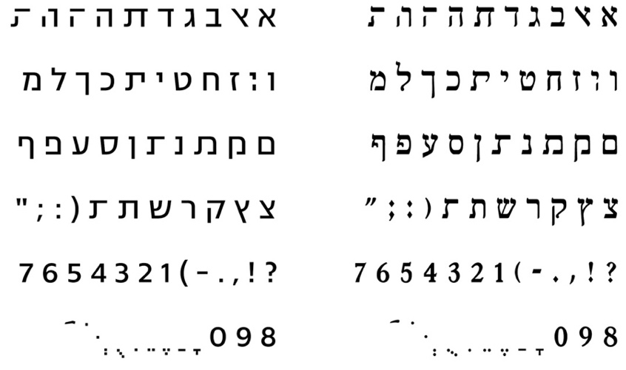
Image (1.19) (Schumer)
Image (1.20) (Schumer)
Schumer’s work shares, in many ways, the essence of the French inclusive writing system. Though it is not a solution for spoken language, it represents a continued desire among speakers to enrich the language with more than just the gender binary.
1.4.C the academy of Hebrew language
Unsurprisingly, the Hebrew Language Academy, following the example of both the Spanish and French Academies, issued its formal denunciation of the neologisms and strategies bringing gender-neutral and gender-inclusive options to the language. The Academy’s “decisions on new words, grammar, orthography, transliteration and punctuation for written Hebrew are binding on all governmental agencies in Israel” (Ghert-Zand, 2018). Dr. Gabriel Birnbaum, “senior researcher at the Academy” said in response to the Nonbinary Hebrew Project, “It’s not worth considering…If anyone wants to invent, they can. If we were asked to invent a new language, we could do what we want. It’s a democracy” (Ghert-Zand, 2018). He underscored “one of the Academy’s goals is to conserve the historical continuity of Hebrew, and that binary gender is part of the Hebrew heritage” (Ghert-Zand, 2018). This stance of maintenance and conservation, though expected from a prescriptivist language institution, is surprising given that 200 years ago no such Modern Hebrew was in existence. During our interview, I asked Gross about the resistance to change despite Modern Hebrew’s infancy; Gross responded with frustration, affirming Eliezer Ben-Yehuda’s innovation and spirit to be an inspiration in their work with the Nonbinary Hebrew Project (Gross, 2020). Yet, Birnbaum stood firm in his conviction during The Times of Israel’s interview, “We don’t just add things out of the blue” (Ghert-Zand, 2018).
1.5 conclusion
This chapter addressed the different strategies and forms created by speakers of English, Spanish, French, and Hebrew to incorporate gender-neutral and gender-inclusive options into their respective languages. Working on a scale from least to most comprehensive, the chapter also outlined to what degree natural gender is embedded in the morphology of each language including pronouns, noun cases, and verbal conjugations. As of the time of this paper, English’s singular they is the only one of the four languages discussed with approval from language institutions; Spanish, French, and Hebrew all received backlash from their language academy as well as speakers. The following chapter will incorporate many of the morphemes presented in this chapter into a survey aimed at assessing to what extent speakers inside and outside of the LGBTQ+ community are familiar with and accepting of the forms and their usage.

Chapter 2: survey and analysis
Within the field of Linguistics, the shift towards a descriptivist view prioritizes the attitudes of speakers over prescriptive authorities like dictionaries and grammarians. As Hord acknowledges in his own survey of pronoun preferences of bilingual speakers, “most languages are used according to shared public consensus, and new terms are not officially instated but are introduced into speech communities organically with the potential to become widespread” (Hord, 2016). With this grassroots understanding of language change, “social attitudes” are “not only as markers of progress but [also] targets for potential transformation” (Hord, 2016). Thus, the popularization of newer epicene pronouns and nonbinary and inclusive forms by speakers suggests the forms may be on their way to becoming a part of the language.
This chapter will present surveys in the case languages of English (§2.1), Spanish (§2.2), French (§2.3), and Hebrew (§2.4) which are designed to assess speakers’ familiarity and usage of the forms presented in the previous chapter. This chapter will also analyze the role which specific demographics like age, identity, and multilingualism may play in the results as well as implications and conclusions which are drawn from the findings (§2.5).
Each questionnaire consisted of three sections: demographic data, word recognition, and sentence ratings which I will discuss below in turn. To the largest extent possible, each language’s survey proceeds in a similar fashion attempting to measure speaker familiarity through recognition of isolated lexemes and contextualized uses of inflectional forms and lexemes in sample sentences. A complete list of questions and answer choices can be found in the Appendices (A-D) following this chapter. The surveys were live for 40 days starting in late January of 2020 and were administered online through the platform of Google Forms. Respondents were recruited through emails, social media posts, listservs, and word-of-mouth. The goal of the survey was to collect data from speakers from diverse backgrounds and identities regarding their familiarity with gender-neutral and gender-inclusive options in their language. Respondents were encouraged to take the survey for all languages which they were at least semi-fluent, thus some individuals may have completed the survey in multiple languages. All responses were anonymous.
  - English
2.1.A demographics
The English survey received 217 responses over the course of the study. The vast majority of respondents were between the ages of 19-25 (65.4%) as shown in Figure (2.1) below.
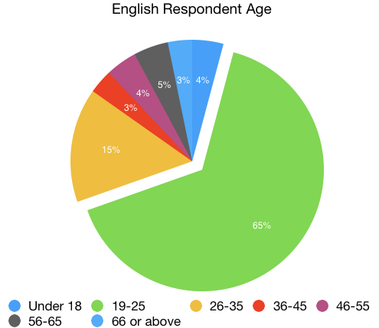
Figure (2.1)
Around half of the respondents for the English portion (50.7%) self-identified as part of the LGBTQ community with an additional 35.9% identifying as allies. Both the young age of respondents and the familiarity with the LGBTQ community could influence the data findings as these individuals may be more familiar with new or changing language trends. This issue is furthered explored in (§2.5) with multivariable analyses.
Figure (2.2) classifies the types of speakers who participated in the survey by percentage. These categories were derived from a series of statements about with speaker’s familiarity with and usage of the given language and these classifications remained consistent across all four language surveys. Please see the Appendices for more information.
Figure (2.2)
The majority of English respondents (78%) were familiar to some extent with another language besides English. Section §2.5 will also compare the monolingual responses to data gathered from bilingual and non-native speakers.
2.1.B isolated identification
After the demographics, the first data section of the survey presents respondents with two sets of lists of isolated lexemes related to pronouns. The first set in the English survey consists of the subject pronouns and includes both the standard he and she alongside neologisms for the epicene pronoun as discussed in Chapter 1 (§1.1.C) and found on the University of Wisconsin, Milwaukee LGBT Resource Center’s pronoun cards (Pronouns 2011, 2016). Participants were asked to select any and all of the forms which they recognized. Figure (2.3) below presents the findings for this section.
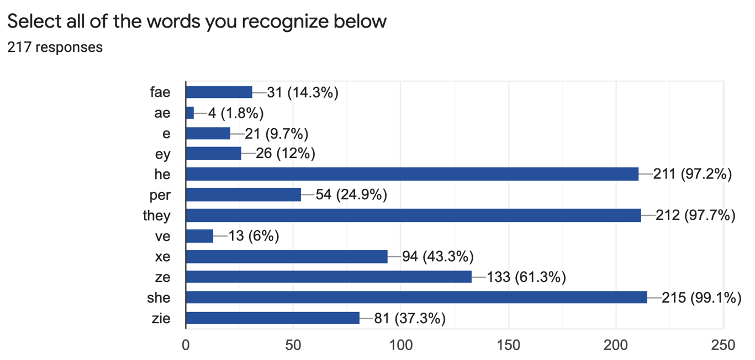
Figure (2.3)
As anticipated, nearly all of the respondents selected he (97.2%), she (99.1%), and they (97.7%) as forms which they recognized. Over half of the participants (61.3%) selected ze as a recognized form. The pronouns xe (43.3%) and zie (37.3%) received a decent amount of recognition, while all of the other forms presented fell below 30%. Though the pronoun form per is included on this list, its high selection rate (24.9%) suggests individuals may be selecting the word for its prepositional meaning.
Findings for the second list of pronouns, shown in Figure (2.4), provides further insight into speaker familiarity through testing the reflexive forms of the same pronouns presented in Figure (2.3).
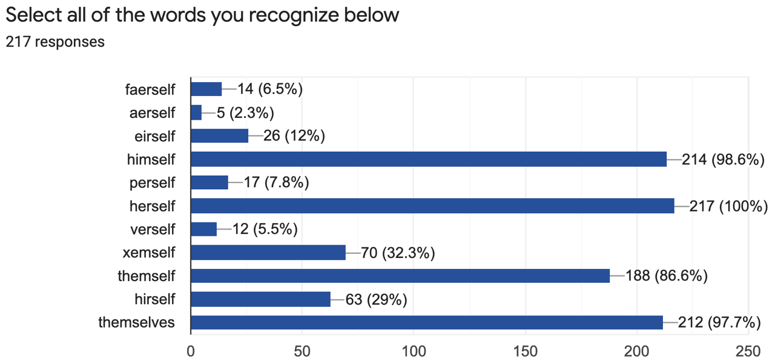
Figure (2.4)
Here, familiarity with the neologisms collapses to only 29% of respondents selecting the reflexive form of ze/zie which is hirself and 32.3% selecting the reflexive for xe, xemself. The consistency in which neologisms are selected in the subject and reflexive forms, however, does point to a level of familiarity in how these forms are accurately conjugated. The knowledge of how to properly inflect pronouns for various contexts is implicitly necessary in using any of these neologisms in integrated speech. This consistency perhaps implies a more nuanced familiarity of the neologisms ze/zie and xe than just mere recognition. This is especially the case with the linking of ze/zie to hirself as the forms do not appear related in their orthography.
Figure (2.4) also presented two options for the reflexive form of they: themselves and themself. The reflexive pronoun themselves was selected (97.7%) at rates comparable with the baseline himself (98.6%) and herself (100%) and could be read as merely referring to the plural form. The issue of themself, however, is quite interesting as it could only refer to singular cases yet it was selected more often (86.6%) than any other form aside from the baseline gendered forms. The themself option is technically ungrammatical in terms of prescriptivist views of English since they can only exist as a plural form in this paradigm. Yet, an overwhelming majority of respondents selected themself as a word they recognized. In the case of singular they, what form are speakers using for the reflexive singular, themself or themselves? Prior to conducting this study, it was assumed that singular they would maintain the same conjugations as the already popular plural and context clues would cue speakers in to whether a singular or plural party was in reference. The prominence of themself, however, suggests that perhaps speakers are deploying new forms or at least ungrammatical constructions for their conjugations of they in singular cases. Section §2.1.C further explores singular they and issues of agreement with the sentence rating data. Though it goes beyond the scope of this paper, testing to see whether individuals actually use singular agreement in rapid speech through elicitations is an important next step.
2.1.C sentence ratings
The final section of the survey presents respondents with a series of eleven sentences and asks that they rank each sentence on a scale from one to four where one signifies “completely ungrammatical” and four means “grammatical and something I would say.” In order to establish a baseline the grammatical sentence “He goes to the store” and the ungrammatical sentence “I were the best” were also included in the section. Figure (2.5) presents the results for these two baseline sentences.
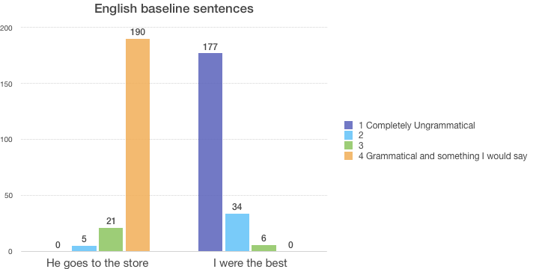
Figure (2.5)
Overall, respondents replied to the baseline examples as expected, though were was some variation in the degree of grammaticality which participants assigned the baseline sentences. This variability must also be taken into account when considering the target data as well.
The remaining nine sentences test various possibilities for singular pronoun forms. For ambiguous contexts, respondents were presented with a singular feminine option (Each person has her calling), a singular masculine option (A citizen should vote for what he loves), and two singular neutral option using they (Each person should was their hands before they eat, Each student must hand in their forms). Figure (2.6) below shows the results for singular ambiguity.
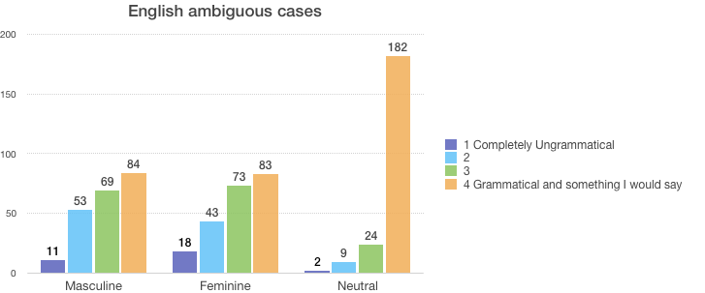
Figure (2.6)
Overall, the distributions for the feminine and masculine pronouns in ambiguous cases are nearly equivalent. The singular they cases, however, were overwhelmingly (83.9%) rated in the four category as “grammatical and something I would say.” Thus, there is also a notion among respondents that some sort of neutral option should be favored in ambiguous cases rather a gendered pronoun regardless of whether its feminine or masculine.
The sentence for singular they in a non-binary case (Jeff loves the ice cream I bought them) received an overwhelmingly high acceptance rate in category four (79.3%). It is possible that respondents interpreted the them as in reference to a plural group and thus gave the sentence a higher grammatical rating. The ambiguous cases, however, show that respondents can conceptualize they as in reference to an ambiguous singular. More data would need to be collected to confirm that they is equally accepted in neutral cases. In comparison, the responses to the use of a neologism in the sentence Xe loves to dance were much more stratified. Figure (2.7) presents the data for xe alongside the same findings discussed for singular they.
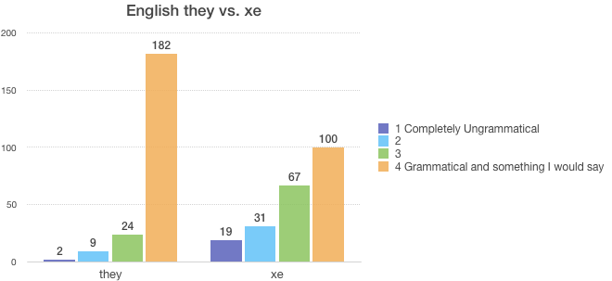
Figure (2.7)
As shown in Figure (2.7), there is much less consensus among respondents with regards to xe—only 46% of responses assigned xe to category four and there was a dramatic increase in ratings for the middle two and three categories. This could also be related to the stipulation in category four that the sentence is something the respondent would say themselves. Disagreement around xe reinforces much of the discourse which posits singular they to be the most salient option for an epicene pronoun.
The final set of sentences measures to what degree usages for singular they are standardized in English with regard to singular or plural agreement. Sentences include the use of they with singular verb agreement (They is ready to go to the show), an instance of the singular form themself (Everyone should take care of themself), and another instance of themself combined with singular agreement (A doctor must introduce themselves before they operates). As shown in Figure (2.8) below, these sentences all received high rates of rejection from respondents.
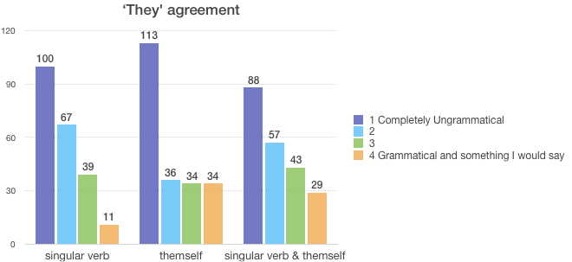
Figure (2.8)
The rejection of themself is particularly interesting given its high rate of selection (86.6%) as familiar form in the Isolated Identification section of the survey. Again, more research and elicitations are necessary to parse whether themself is a form speakers actually use. Overall, it seems clear that respondents prefer singular they to agree grammatically with plural verb conjugations and already existent plural case endings like themselves.

2.1.D summary of findings
In summary, the English survey reinforces the discourse of singular they as the preferred pronoun for ambiguous cases over options of both masculine and feminine pronouns. Respondents also rated singular they as more grammatical, familiar, and preferable than the neologisms like xe. However, participants did recognize ze/zie/hirself and xe/xemself as semi-popular options and respondents demonstrated some level of familiarity with the different case forms for these two neologisms. Despite the prominence of themself in isolated identifications (§2.1.B), respondents consistently rejected its usage in actual sentences (§2.1.C). Participants consistently marked singular agreement for singular they as ungrammatical in the sentence ratings while examples with plural agreement were consistently accepted. Elicitations of actual speech would be necessary to resolve the dissonance in the findings in regards to themself.
  - Spanish
2.2.A demographics
The Spanish survey only received 46 responses—the lowest amount out of all four languages. Similarly to the English, the majority (70%) of respondents also are in the age category of 19-25. Figure (2.9) shows the age breakdown for Spanish speaking participants.
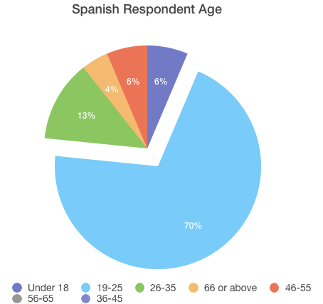
Figure (2.9)
Over half (56.5%) of the respondents for the Spanish portion self-identified as part of the LGBTQ community with an additional 17.4% identifying as allies. The Spanish survey also had a significant number of respondents identify as outside of the LGBTQ community (26.1%).
Figure (2.10) classifies the types of speakers under the same guidelines as used throughout all four surveys.
Figure (2.10)
All of the respondents spoke a language to some degree besides Spanish and 61% identified as non-native speakers of Spanish. No respondents identified themselves as monolingual Spanish speakers. This will be taken into account in the multivariable analysis in §2.5 which will assess whether bilingualism increases the chance for recognition and/or acceptance of changes to the closed-class categories of pronouns, inflections, and cases to create gender-neutral options.

2.2.B isolated identification
The first section of the Spanish survey included three sets of lexemes: pronouns, singular nouns, and plural nouns. All three lists employed-e, -x, and -@ as the three main suffixes for neutral and inclusive forms as mentioned in Chapter 1.
The pronouns list included the baseline forms él, ella, usted, ustedes, nosotros, and nosotras alongside neologism forms for the third person singular and plural which are gendered in Spanish. Figure (2.11) below presents the data for pronoun ratings.
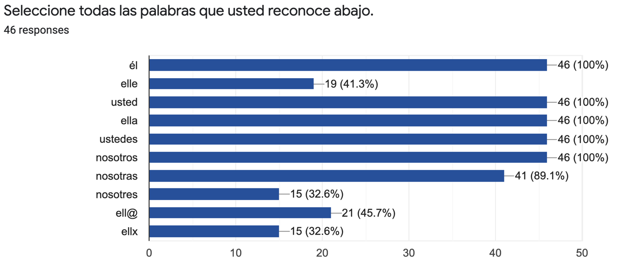
Figure (2.11)
All test forms except nosotras received 100% recognition, indicating that most participants understood the activity and had proficiency in Spanish. The drop to 89.1% ratings for nosotras suggests, perhaps, that participants considered a feminine form in isolation to be slightly less correct than its masculine counterpart nosotros. This assumption is linked to the concept of the masculine form as neutral within the language. Respondents rated the four neologisms included in the pronoun set, elle (41.3%), ell@ (45.7%), ellx (32.6%), and nosotres (32.6%), significantly lower than the baseline forms, though ell@ received slightly more popularity than the rest.
The neologistic suffixes -@, -e, and -x were also applied to singular and plural nouns as shown in Figures (2.12) and (2.13), respectively.
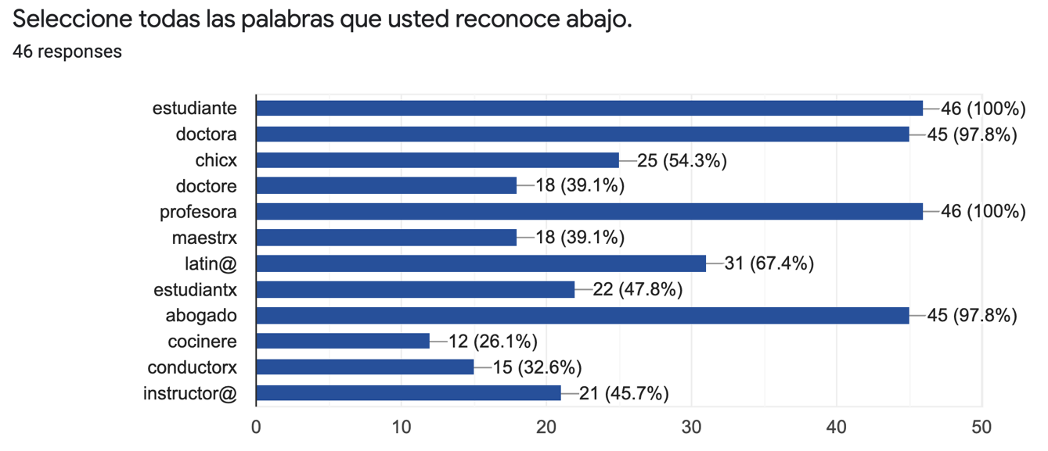
Figure (2.12)
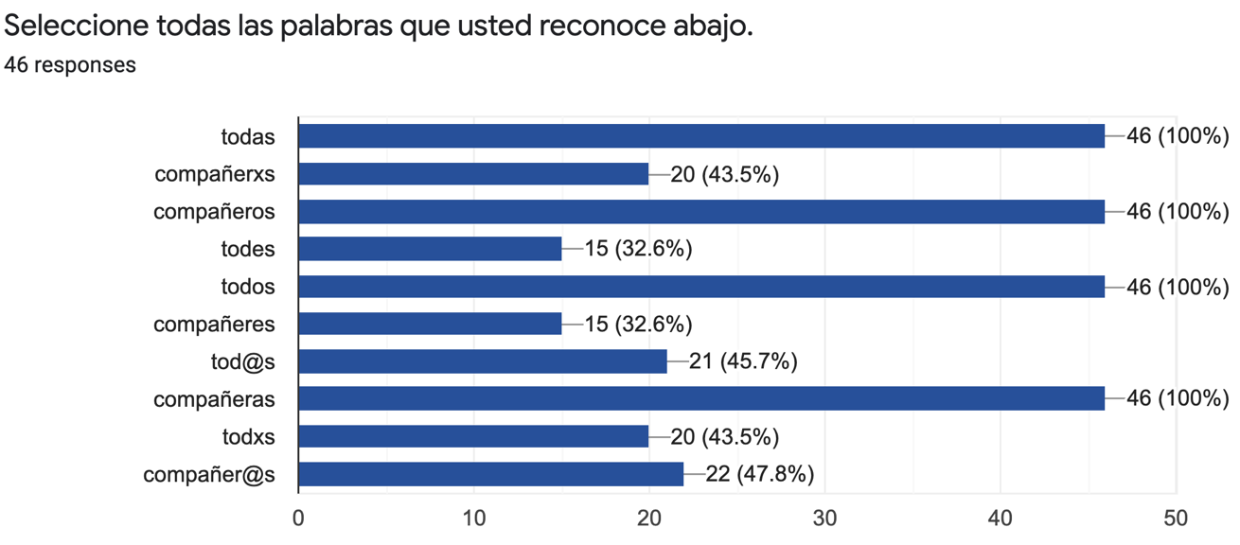
Figure (2.13)
In the data above, the test cases estudiante, profesora, todas, todos, compañeros, and compañeras all received 100% recognition ratings, regardless of the natural gender being feminine or masculine. This refutes the findings in the pronoun list in which nosotras received noticeably lower ratings than the masculine pronoun forms.
The word estudiantx shown in Figure (2.12) was included in the data set to measure overapplication of neologism usage since the noun estudiante is already gender-neutral. Interestingly, estudiantx received 47.8% acceptance, a higher rating than most of the other neologisms. Do speakers intuit which nouns do not mark for natural gender in Spanish? Are they more accepting of a neologistic epicene in these cases? On the other hand, perhaps Spanish speakers are unaware of the few already existent neutral nouns in the language and thus overapply gender-neutral neologisms to these words.
With 51.6% acceptance, the epicene suffix -@ was the most widely accepted form across both singular and plural environments. While 42.6% of participants selected the suffix -x, only 32.6% recognized the suffix -e. This is notable as the -e is actually the epicene which more clearly resembles the rest of the Spanish orthography and maps onto the phonology of the language. As discussed in §1.2.C, -e also appears in some cases as an epicene suffix in Spanish (like in estudiante). Despite its preexistence in the language and adaptability to both orthography and phonology, -e is rated significantly lower among participants of this study. The epicene -e in Spanish does not fully follow the success of they in English, at least not yet. Additional work should be done in the next few years to see whether -e becomes more prominent with time.

2.2.C sentence ratings
The sentence ratings section of the Spanish survey contained two baseline sentences: El chico es hermoso and Ella es tan bonita. Figure (2.14) below shows the distribution of survey responses for the baseline sentences.
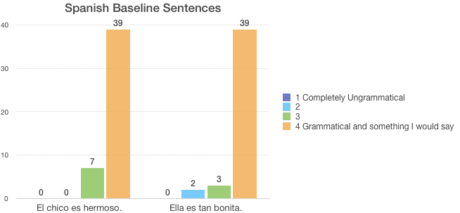
Figure (2.14)
Both baseline sentences received high ratings, though there was some variability in responses.
The three set of sentences tests for the acceptance of subversive alternation between masculine and feminine forms. Sentences (2.15), (2.16), and (2.17) below present the two forms with glossing to illustrate the natural gender alternation.
(2.15) Ella está enferm-o
3.NOM.SG.F is.PRS sick-M
‘She is sick’
(2.16) El doctor fue gracios-a
DET.M doctor.M was kind-F
‘The doctor was kind’
(2.17) Esta profesor es mi preferida
this.F profesor.M COP my preferred.F
‘This professor is my favorite’
While this approach does not escape the binary, it does work to signal to the hearer that the individual in reference cannot be properly placed into a clear natural gender. Evidence for this method was not explicitly mentioned in the literature review for Spanish and French in Chapter 1, though Moehlman invokes this analysis in his 2018 analysis of modern Hebrew (Chapter 1, §1.4.B). As shown in Figure (2.18) below, the first two sentences with alternation received mostly ungrammatical ratings though there was some dispersion with the degree of rejection.
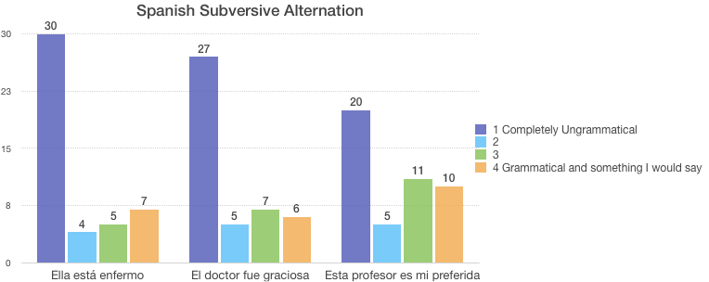
Figure (2.18)
Participants ratings for the third sentence (2.17), however, are fairly balanced. The only difference between this sentence and the former two is that the gender agreement is disrupted across three lexical items esta, profesor, and preferida. The disruption of concord lies only with the noun profesor which requires the feminine suffix -a to match the determiner and adjective of the sentence. Due to multiple gender bearing markers, the disagreement may not have been as evident to respondents in this third sentence. On the other hand, perhaps there is wider acceptance of gender discord in sentences with complex gender layouts.
The survey also included two sentences using the epicene neologism elle (discussed in detail in Chapter 1, §1.2). Figure (2.19) below presents the findings for these sentences.
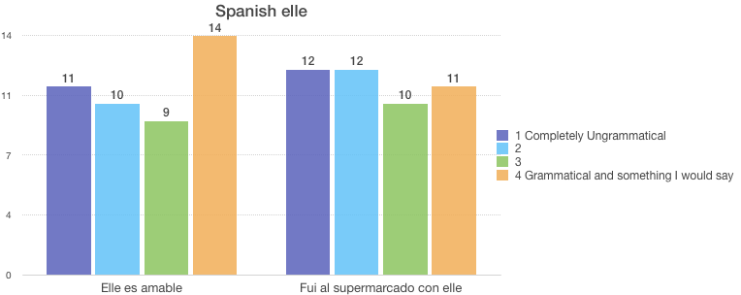
Figure (2.19)
As shown above, responses were quite evenly distributed across all four degrees of grammaticality. While there is disagreement, half of the respondents marked these forms in the “4 grammatical and something I would say” and “3” columns. This suggests that the epicene pronoun elle is gaining acceptance in the wider community and is not merely written off as ungrammatical by a significant number of the respondents.
The Spanish survey also included three sentences with the neologistic suffixes -@, -x, and -e for noun forms. Responses to these examples are given in Figure (2.20).
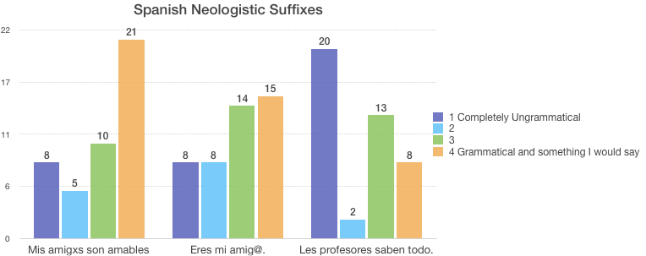
Figure (2.20)
The first sentence, using the suffix -x in amigxs, received the highest rate of acceptance with 70% of respondents placing it in the top two categories for grammaticality. The sentence using -a had a similar degree of placement though many more respondents placed the sentence in “3” rather than “4 grammatical and something I would say.” Finally, the case with -e was rated the lowest, though this sentence also included the neutral determiner les.
The final set of sentences in the Spanish survey aimed to test the phenomenon of listing all forms in a given sentence. The first sentence, En mi grado estamos acostumbrados, acostumbradas, y acostumbrades a defendernos entre sí, was taken from the video of the Argentinian girl using gender-neutral speech (discussed in Chapter 1, §1.2.C). The second sentence applies the same rules of repetition: Todos, todas, y todes necesitan el libro. Figure (2.21) below shows participant responses for these entries.
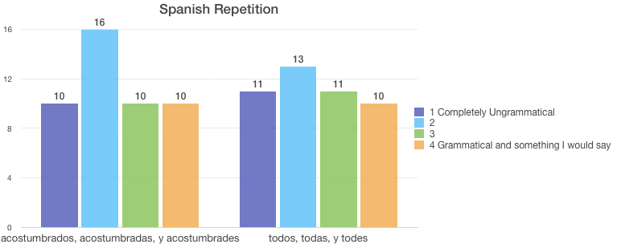
Figure (2.21)
Both repetition sentences received a fairly even split amongst participant responses, quite comparable to the distributions in Figure (2.19) for the epicene elle. Participants rated these sentences less in the “1 completely ungrammatical” column than the sentence with the -e suffix alone in Figure (2.20). Thus, there is a notion that a repetition of all of the forms, masculine, feminine, and neutral marked with -e, is slightly more grammatical than the neutral form alone. The final section of this chapter will explore whether any of the demographic factors play a role in the distribution of acceptance.

2.2.D summary of findings
The Spanish survey tested the epicene morphemes -@, -x, and -e, finding the first to be the most widely accepted in citation form. Subversive alternation was consistently rejected by the majority of respondents and neologistic forms were rated above this technique. The repetitive method of listing forms and the epicene pronoun elle both received equal distribution of acceptance and rejection. Cross-comparison of this data with demographics in the final section of this chapter may illuminate whether specific groups are consistently embracing or rejecting these forms.
  - French
2.3.A demographics
The French survey was completed by 130 respondents, the majority of whom, again, identified as between the ages of 19 and 25. Figure (2.22) below illustrates the age demographics for respondents.
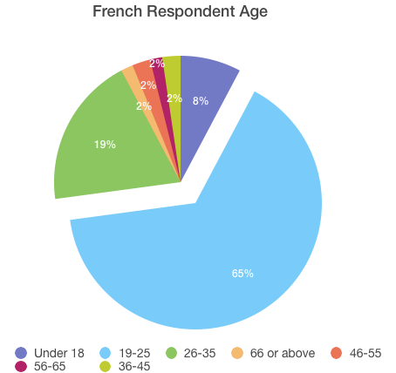
Figure (2.22)
Nearly all respondents self-identified as part of the LGBTQ community (84.6%) or an ally (11.5%). Figure (2.23) below shows the degrees of fluency for the French respondents.
Figure (2.23)
Only 3% of respondents selected that they were monolingual speakers. Despite the lack of monolingual speakers, the French survey did receive a large amount of native speakers (71%) who were either bilingual or semi-fluent in another language.
2.3.B isolated identification
The French isolated identification section included the third person gender-neutral singular forms iel, il, os, eil, ille, and elli and gender-inclusive plural forms iels, eils, illes, and ellis alongside the standard gendered forms. Figure (2.24) below shows the degree of acceptance for each form.
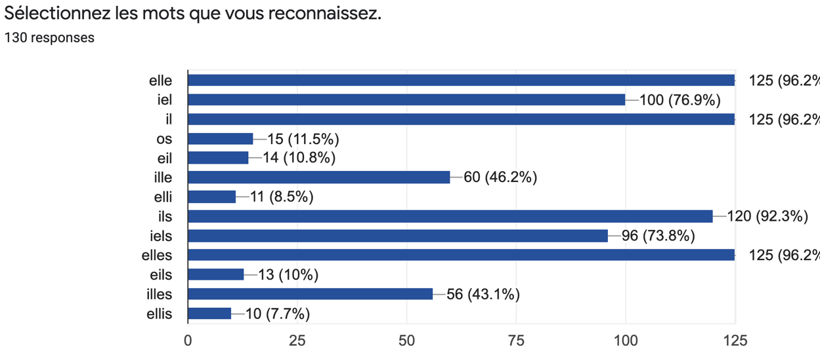
Figure (2.24)
The standard forms elle, il, ils, and elles all received relatively high rates of acceptance, though there is some degree of errors as not every participant recognized these forms. The epicene neologism iel (76.9%) and its plural counterpart iels (73.8%) received quite high ratings of acceptance as well, with around 30% higher ratings of recognition than the Spanish epicene elle in §2.2. The French neologisms ille (46.2%) and its plural form illes (43.1%) received the second highest amount of recognition amongst the neutral forms, though there is a notable drop of 30% between these epicene pronouns and iel. The rest of the neologisms, hovering around 10% or less, fell nowhere near iel and even ille.
The second list of lexemes in the French survey tested for inclusive writing methods. The results for this section are shown in Figure (2.25) below.
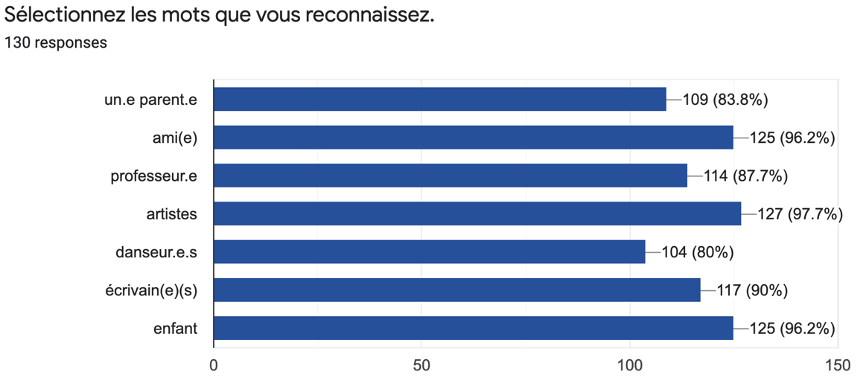
Figure (2.25)
The written form ami(e) (96.2%) received comparable recognition to the baseline forms enfant (96.2%) and artistes (97.7%). However, all of the forms separated by commas or periods received overwhelming recognition, 80% and above. Thus, inclusive writing was widely accepted among survey participants for both singular and plural nouns.
2.3.C sentence ratings
The French sentence rating section tested for subversive alternation, inclusive writing, the pronoun iel, and a few other combinations of neologisms. The list also included the baseline sentence Je veux dîner. The distribution for the control form is shown in Figure (2.26).
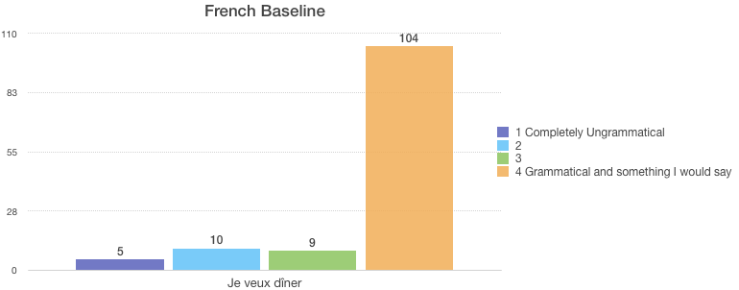
Figure (2.26)
There was some variance in responses to this control case which should be taken into account for the results of the test cases as well.
Sentences (2.27) and (2.28) below illustrate two instances of subversive alternation.
(2.27) Il est très joli-e
3.NOM.SG.M COP very pretty-F
‘He is very pretty’
(2.28) Elle est gentil
3.NOM.SG.F COP kind.M
‘She is kind’
Respondents found these sentences to be primarily ungrammatical as shown in Figure (2.29).
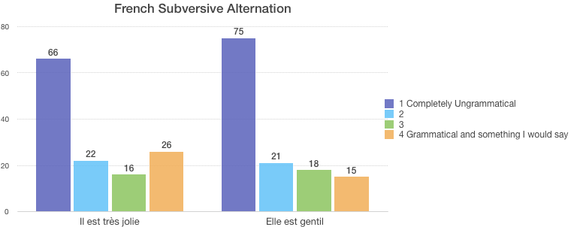
Figure (2.29)
However, on average, 28% of respondents rated the subversive alternations in the top of categories for grammaticality. Since 71% of participants self-identified as native speakers, it is unlikely that they were unaware of the basic violations of gender harmony. This means that there is some degree of acceptance for gender discord among the French survey respondents.
The next set of sentences aimed to test reactions to inclusive writing when it is integrated into a complete sentence rather than merely in citational format. The inclusive writing was again written both with parenthesis (Qui est cet(te) ami(e)?) and punctuation marks (Mes étudiant·e·s sont intelligent·e·s.). Figure (2.30) shows the respondents’ ratings for these cases.
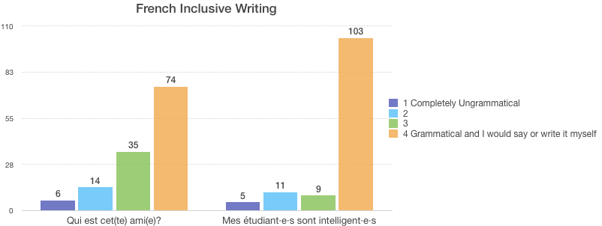
Figure (2.30)
While both cases received overwhelmingly grammatical ratings, the second sentence using punctuation marks had a slightly more unanimous response with 80% of participants rating it as “4 grammatical and I would say or write it myself.” This could also be related to the fact that the first form is a question while the second is a statement. Regardless, it is clear that inclusive writing is accepted both in citation form and when embedded in a sentence across multiple nouns and adjectives for agreement.
The survey also included a sentence using the epicene pronoun iel to test whether it displayed levels of acceptance comparable to its citation form. Figure (2.31) below compares the sentence using iel (Iel est médecin) with the test sentence (Je veux dîner).
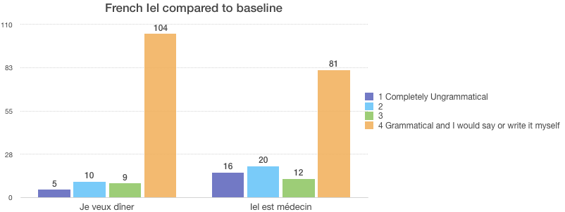
Figure (2.31)
Once again, iel has rates of acceptance comparable to the standard form. This furthers the evidence in the citation forms section that iel has already gained immense popularity as a gender-neutral pronoun. Its 72% placement in the top two tiers of grammaticality is comparable with the rates of acceptance singular they received in the English survey. This is notable since, unlike singular they, iel is a neologism that did not previously exist in French. The case of iel proves that a neologisms can gain as much popularity as an already existent form for a gender-neutral alternative.
The final two sentences of the rating section tested some of the forms found in the literature review for French in Chapter 1, including the determiner læ, the third person possessive pronoun saon, and the first person possessive pronoun maon. Figure (2.32) below shows the data for these neologisms.
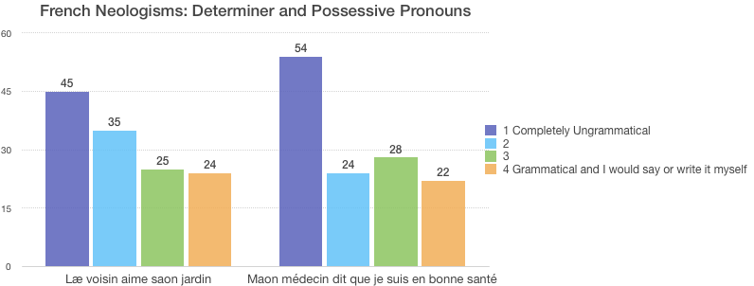
Figure (2.32)
Both sentences received a fairly even distribution of ratings, suggesting that these forms are recognized and approved to some extent but not yet as widely accepted as forms like iel.
2.3.D summary of findings
The French survey found participants overwhelmingly in support of iel as a gender-neutral pronoun option along with its plural form iels. Inclusive writing was also widely accepted both in citational format and when embedded in sentences. Subversive alternation in French was rejected by most respondents and there was an even distribution of opinions regarding the forms læ, saon, and maon.
  - Hebrew
2.4.A demographics
The Hebrew survey received 65 responses over the course of data collection. Exactly half of the participants were between the ages of 26 and 35, a shift from the other language respondents which all primarily fell into the category of 19 through 25. The degree of impact age has on familiarity will be further unpacked in §2.5. Figure (2.33) below depicts the distribution of age for the Hebrew speaking participants.
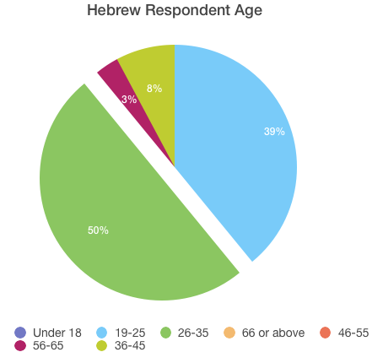
Figure (2.33)
Participants were quite evenly distributed in regards to their identification—35.4% selected that they were part of the LGBTQ community, 38.5% identified as allies, and 26.2% selected neither. The distribution of speakers, shown in Figure (2.34) below, is also an important factor as both heritage speakers and native fluent speakers were among the respondents.
Figure (2.34)
Only 9% of respondents categorized themselves as monolingual, though 60% identified as native speakers of Hebrew. Also, a significant percentage of participants (21%) considered themselves to be either not fluent or use the language rarely. This is crucial in understanding attitudes of language change as it is hypothesized that perhaps this group of primarily heritage speakers are more likely to make drastic changes to the language’s grammar to accommodate gender-neutral and gender-inclusive language. This point will be assessed cross-linguistically in §2.5.
2.4.B isolated identification
The Hebrew survey included three sets of isolated identification: singular and plural nouns, second person pronouns, and third person pronouns. Figure (2.35) below presents the baseline gendered nouns תַלְמִידָה, תַלְמִיד, תַלְמִידוֹת, תַלְמִידִים and the two neologisms for a gender-neutral singular case ending תַלְמִידֶה, and a gender-inclusive plural ending תַלְמִידוֹתִים.
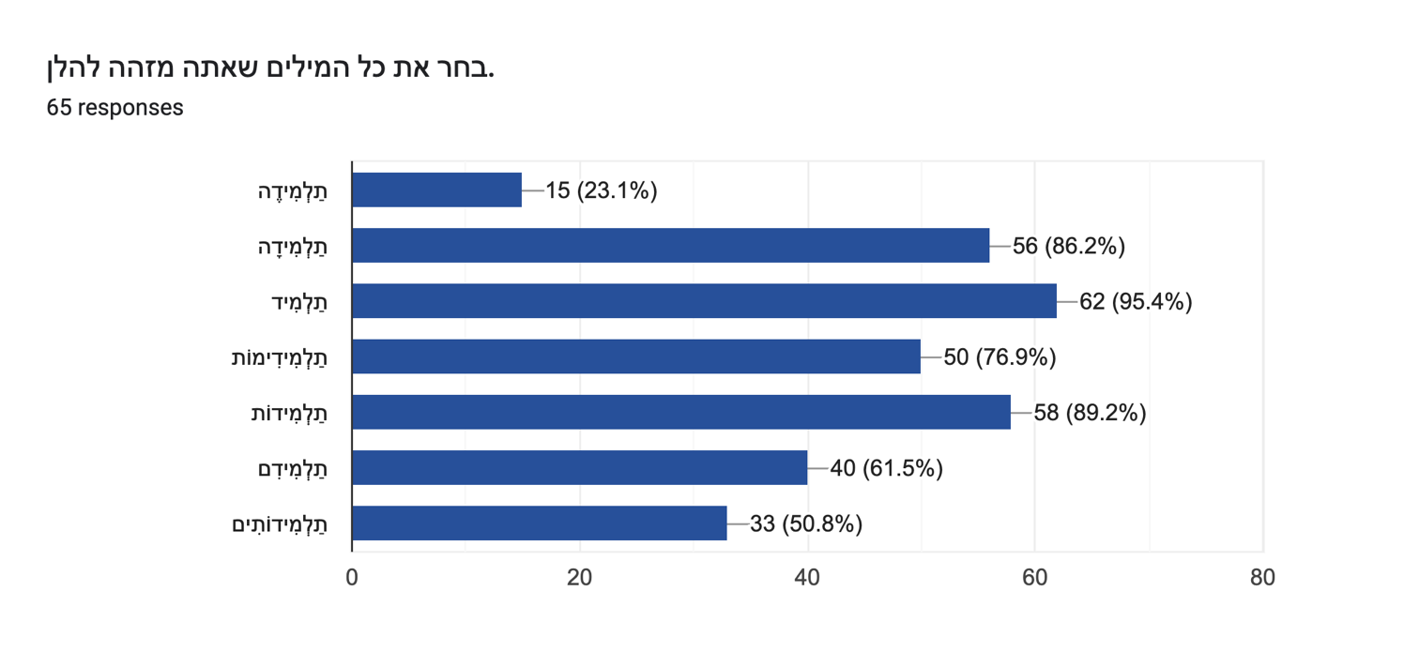
Figure (2.35)
There seems to be some degree of error with the baseline forms, none of which received 100% recognition. The gender-neutral singular form תַלְמִידֶה with the morpheme [-ɛ] only received 23.1% recognition. The gender-inclusive plural form, on the other hand, which combines the plural masculine ending [-im] and the plural feminine ending [-ot] received 50.8% recognition. Thus, in the case of Hebrew, respondents more often recognized a form which makes use of already existent forms than the singular neologism.
This trend holds true for the neologistic pronoun forms as well which all received remarkably low rates of recognition. Figures (2.36) and (2.37) below show the distribution of second person and third person pronouns respectively.
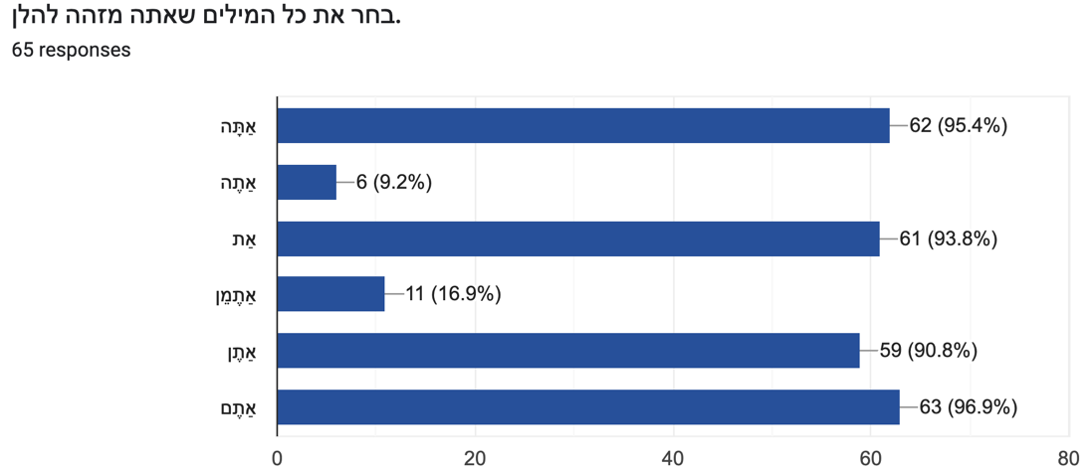
Figure (2.36)
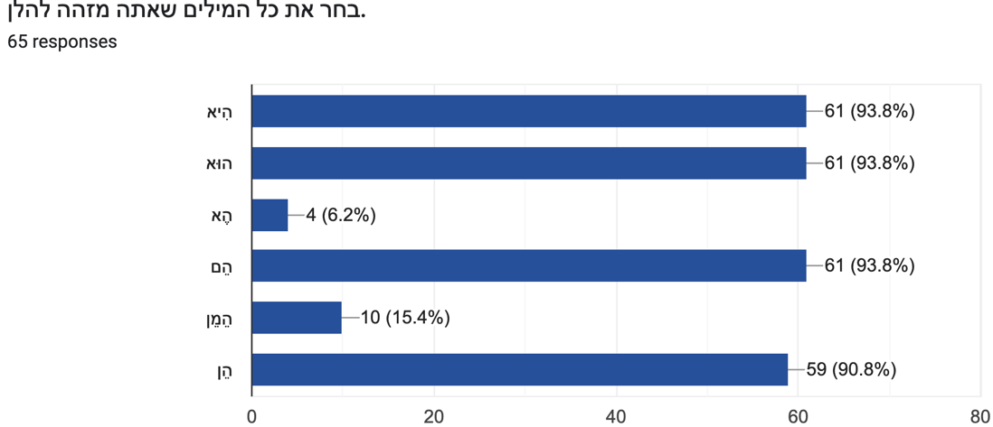
Figure (2.37)
The lack of acceptance for the Hebrew neologisms, especially in contrast to Spanish and French initiatives, may be related to the divide between diaspora and Israeli efforts (discussed in detail in Chapter 1, §1.4).

2.4.C sentence ratings
The sentence rating section tested subversive alternation and various combinations of the neologisms from the Nonbinary Hebrew Project (Chapter 1, §1.4). Figure (2.38) below illustrates the distribution for the Hebrew baseline sentence אַתָּה אוֹכֵל עוּגָה ‘He eats cake.’
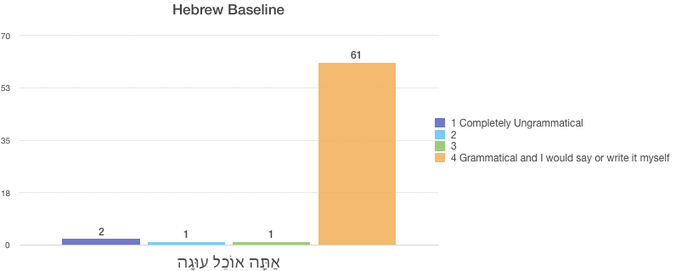
Figure (2.38)
The majority of participants correctly placed this sentence in the grammatical column.
Two sentences in the section included subversive alternations. As shown below, sentence (2.39) uses the first person forms and has discord in the gender marking on the verb and adjective; sentence (2.40) has dissonance between the third person singular pronoun and the gender marking on the verb.
(2.39) אֳנִי חוֹשֶׁבֶת שְאֳנִי מַמָש חָכָם
[ani xoʃɛv-ɛt ʃɛ-ani mamaʃ xaxɛm]
1.NOM.SG.N think-F that-1.NOM.SG.N very smart.M
‘I think that I am very smart’
(2.40) הוּא רוֹצָה מַיִם
[hu rots-a maIjim]
3.NOM.SG.M want-F water
‘He wants water’
As shown in Figure (2.41) below, both iterations of subversive alternation were rated across all four columns.
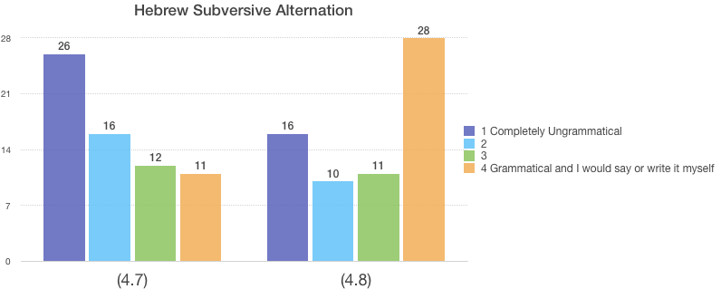
(2.39) (2.40)
Figure (2.41)
The higher rating of sentence (2.40) may be because modern Hebrew is rarely written with vowels and the only distinction between the masculine and feminine forms for ‘want’ are in the vowels. Thus, some respondents may not have caught that the verb was actually marked with feminine gender and in therefore in discord with the masculine pronoun which precedes it. Even in sentence (2.39), however, a significant number of participants (35%) recognized the subversive alternation as grammatical or almost grammatical (columns 4 or 3).
The final three sentences tested neologisms forms for the neutral verb conjugation with the morpheme [-ɛt] (אֳנִי עוֹשֶת אֶת הַעֲבוֹדָה שֶלִי ‘I do^{N} my work’), the neutral verb conjugation with the morpheme [-ɛ] with the third person singular epicene pronoun (הֶא לוֹמֶדֶה ‘They.N learn.N’)
third person singular epicene pronoun, and the second person plural pronoun with an inclusive verbal conjuation (אַתֶמֵן רוֹצִימוֹת לִרְקוֹד ‘You.N all want.N to dance’). Figure (2.41) below shows these three sentences in order.
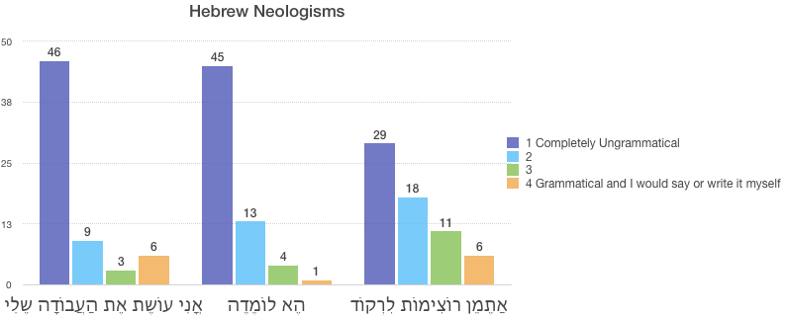
Figure (2.41)
The plural forms in sentence three were much more widely accepted than the singular neologisms—a pattern consistent with the findings in the isolated identification section. Both sentences with singular neologisms were primarily rejected by participants, signaling that the forms of the Nonbinary Hebrew Project have yet to gain popularity with the larger Hebrew-speaking public. Only time will tell whether these forms will be taken up as a new standard.
2.4.D summary of findings
The Hebrew inclusive plural ending [-imot] was certainly the most widely accepted form among those tested, perhaps due to its inclusion of two already existing gendered forms in the language. All other neologisms were primarily rejected among participants, though a small group of participants consistently marked them as grammatical. Subversive alternation hovered somewhere in the middle, receiving a fairly even division among participants in regards to its grammaticality.
  - Multivariable analysis
The following section will analyze the degree to which the demographic factors of age, membership in the LGBTQ+ community, and language ability played a role in participant responses. For simplification, these factors will be measured against a sum variable rather than individual forms. This variable is the percentage of nonstandard forms an individual in the given category recognized or rated as grammatical. Nonstandard forms include neologisms and the usage of words in a novel context. Information from both the isolated identification and sentence ratings comprises this variable.
2.5.A age
The age of participants is crucial to consider when accessing language change since it is a helpful measure in determining how integrated a given phenomenon is to the wider speaking population. For example, if only respondents ages 18 and under recognized the forms of gender-neutral language, that is indicative of either a type of speech used to socially mark membership in the younger age group or that the speech is still in its infancy and has yet to reach older speakers. Figure (2.42) below shows the breakdown of age for all four languages combined compared to the percentage of forms recognized by participants.
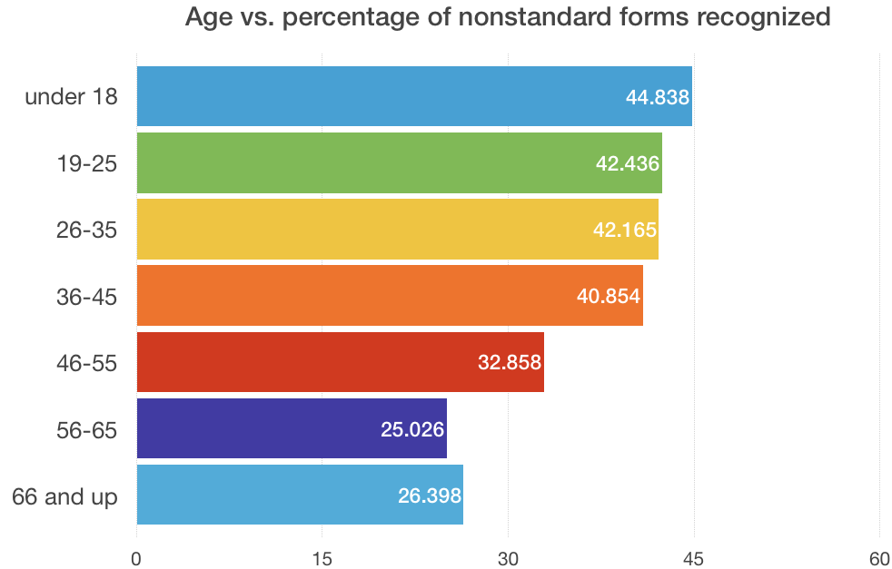
Figure (2.42)
While the first four categories remain relatively uniform, there is a clear tapering off that occurs in the age group 46-55. Thus, across English, French, Spanish, and Hebrew, it is those below the age of 45 who are generally more familiar with the gender-inclusive and gender-neutral options in their languages. This is age-graded variation is consistent with general trends in sociolinguistics, “Adolescents will generally use more non-standard varieties than younger adults (non-prestige varieties, often specific ‘anti-prestige’). From adolescence to adulthood the use of non-standard forms of speech will gradually decrease in favour of more standard forms of speech (prestige varieties) until a particular stage in late adulthood” (Age, 2020). Thus, the addition of gender-neutral grammar mirrors the sociolinguistic trend of age tapering associated with other language changes.
Interestingly, the age drop off point for familiarity actually varied by the language. Figure (2.43) below shows the same breakdown of age compared to percentage of nonstandard forms recognized for English and French.
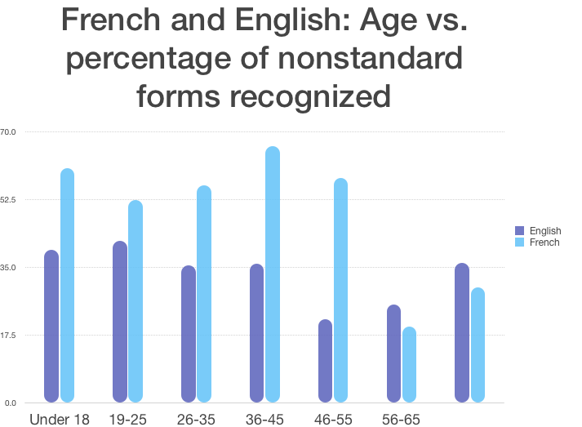
66 and up
Figure (2.43)
As shown in Figure (2.43), the French average falls at the age range of 56-65 rather than 45-56. The English average, on the other hand, falls and 46-55. Additionally, English and French averages actually rise slightly between their respective low point and the “66 and up” category. In the English case, the average for the oldest age group is actually comparable to that of the younger ages. This is likely due to outlier responses since there were fewer participants for the English 66 and up demographic.
2.5.B Language ability
The survey also found links between a participant’s ability with the language in question and their familiarity with gender-neutral and gender-inclusive language. Working within the assumptions of closed-class theory, one may hypothesize that native and fluent speakers who use a language frequently would be more innately aware of the underpinnings of that languages structure and thus more apprehensive to make largescale changes to pronouns, verbal conjugations, and gender agreement. The results of this survey, however, yield the antithesis of such an assumption. Figure (2.44) below shows the breakdown of nonstandard forms by type of speaker.
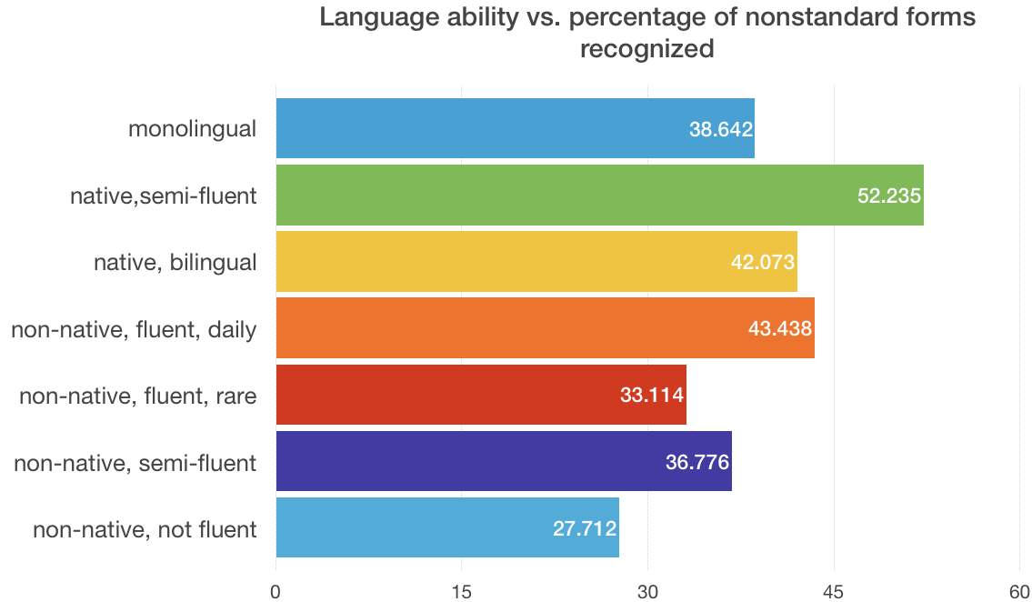
Figure (2.44)
The low result for monolingual speakers is due to a lack of monolingual participants in the Spanish survey. On a continuum where monolingual speakers are the most familiar with and reliant on the given language and non-native not fluent speakers are the least, there is a general tapering off from one end to the other with regards to nonstandard form recognition. Those that are more familiar of the language like monolingual, native, and fluent speakers overall, recognize more forms than their non-native non-fluent counterparts. Also, speakers without fluency in a second language, including monolinguals and native semi-fluent (meaning native speakers who are only semi-fluent in another language), were more likely to recognize nonstandard forms than their multilingual counterparts. Thus, those who are more aware of and familiar with the closed-class distinctions of their language are actually the ones more willing to change grammar classified in this supposedly static category.
2.5.C member of community
The final demographic measured in this section is the identity of participants. The survey asked each respondent to select whether they identified with the LGBTQ+ community, as an ally, or neither. This is significant as it is expected that individuals within the LGBTQ+ community will have higher percentages for nonstandard forms recognized. As hypothesized, identity within or in allyship with the LGBTQ+ community does correlate with percentage of forms recognized. Figure (2.45) below shows the clear relationship.
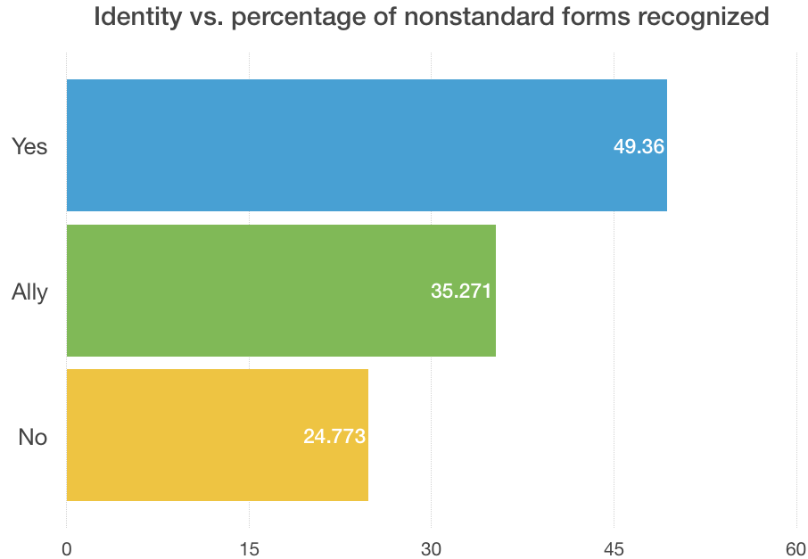
Figure (2.45)
If ally and non-affiliated participants also have relatively high percentages of recognition, this signals that the gender-neutral and gender-inclusive forms for a given language have reached the wider community. Thus, Figure (2.46) below analyzes the data by language.
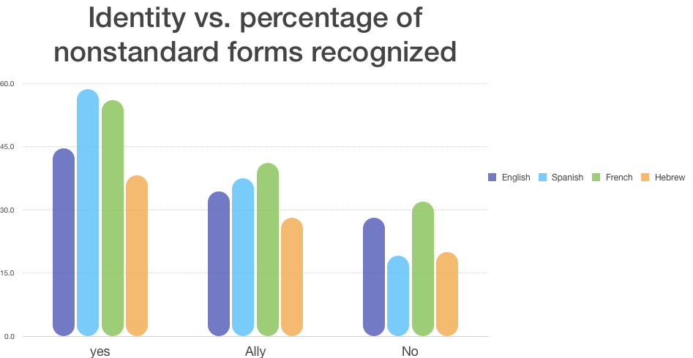
Figure (2.46)
English has the most consistency across all identities, with a 10% difference between members of the LGBTQ+ community and allies and only another 6% between allies and nonaffiliates. Reflecting the literature review around gender-neutral options in English, this data suggests that gender-neutral and gender-inclusive language is fairly well integrated into mainstream English-speaking society. Hebrew most closely emulates English with a 10% and then 9% drop between the categories, though overall Hebrew had the lowest levels of recognition. This could be due to the disconnect between forms created in the diaspora and what Israelis are working towards. Spanish has the largest dissonance between the identities, decreasing by 21% between community members and allies and another 18% between allies and nonaffiliates. French falls somewhere in between Spanish and English. Thus, it appears as though English gender-neutral and gender-inclusive language is at the forefront of reaching the larger public and Spanish forms have not yet reached this level of acceptance in wider society.

Conclusion: Where to go from here
The gender-neutral and gender-inclusive language movements are certainly making an impact on language usage for speakers of English, Spanish, French, and Hebrew. While both English and French speakers appear to have endorsed epicenes among the larger community, the cases of Spanish and Hebrew remain undecided. The goal of revolutionizing language, asking speakers to shift their most basic speech patterns, is no small task. Large-scale popularity is a key factor in measuring whether other forms are on the trajectory of these more prominent cases; “It is an undeniable fact that language evolves, but how it evolves cannot be dictated by a minority group. The reason that words like ‘selfie,’ ‘twerk’ and ‘lol’ are now in the dictionary is entirely due to the fact that millions of people use these words on a daily basis, and, most importantly, understand each other” (Jenner, 2018). Jenner continues, “The question surrounding this new use of language is not whether it is right or wrong, it is whether it will last. Are we seeing a language revolution that will be taught in history classes as students read Old Spanish with all its finicky genders, or merely a fad that will rise and fall in popularity as society sees fit?” (Jenner, 2018). As nearly all of the gender-neutral forms are neologisms, acceptance of these forms depends heavily on whether a “cooked construction” ever become “spontaneous speech,” “inherently unconscious, like breathing, or walking without falling” (McWhorter, 1998). While the repurposing of the already existent pronoun they does not involve an overturning of an entire grammar, the rising success of the French epicene iel/iels shown in the language survey demonstrates that neologisms do hold potential at least in written recognition.
The transition to rapid speech requires yet another step in the process of acceptance for gender-neutral and gender-inclusive language. As McWhorter notes, “self-conscious alternation is unlikely to ever go beyond a tiny segment of society with a particularly strong interest in demonstrating the commitment to gender-neutral speech” (McWhorter, 1998). Even for the case of singular they, which already existed as a plural pronoun in the language, “learning to use the third-person singular they fluently… takes most people a lot of practice, and many people are unwilling to make the effort” (Enke, 2016). Gender-neutral and gender-inclusive language also faces the added barrier of a homophobic and transphobic speech community. Enke notes that the success of epicene language is dependent on shifting the social perceptions of its referents: “as long as trans and genderqueer embodiments are stigmatized or unimaginable, and as long as gender-neutral pronouns are unappreciated in the vast majority of contexts, using them may feel like aggressively speaking a foreign (queer) language” (Enke, 2016).
Hector Alamo, an extremist blogger, expresses exactly this sentiment, tying gender-neutral and inclusive language to a liberal plot: “language monitors sanitize words with x’s and @’s to make sure we’re not corrupted (or stay corrupted)” (Alamo, 2015). Alamo states, “Man/Woman/X is born free, and everywhere his/her/their language is in chains. In the name of inclusivity, during the course of the last half century the English language has slowly and surely been bulldozed and paved over. Now, too, begins the bulldozing of Spanish…with the goal of creating a linguistic parking lot” (Alamo, 2015). Other posts on his blog target the liberal agenda and include homophobic and racist reasonings. Alamo’s rejection of change is closely tied to his supremacist ideology. Yet, he is only one person representing an extreme viewpoint. No one person, however, can stop language change: “prescriptivists grammarians call the new form sloppy and wrong. This sort of thing cannot stop the language from changing because nothing can…before long no one, grammarian of civilian, even remembers that the now accepted form was even ever considered a problem” (McWhorter, 1998). The question then becomes where the general speech community situates themselves in relation to extremists like Alamo.
In hopes of teaching more speakers about gender-neutral and inclusive options, literature surrounding the language and nonbinary identity has grown. In their graphic novel A Quick & Easy Guide to They/Them Pronouns, Bongiovanni creates an accessible window into why the language is important in English. Bongiovanni notes the inevitably dynamic properties of language and assures apprehensive readers that anyone can learn gender-neutral language with practice: “The more you use gender-neutral pronouns the more naturally it will come to you” (Bongiovanni, 2018). The guide also acknowledges that mistakes will happen and comforts readers that these mistakes are a necessary and understandable part of the process. Bongiovanni “[i]t’s such a deeply ingrained reflex that it’s near completely subconscious. It makes unlearning this language extremely challenging. The only way to improve is with time and practice” (Bongiovanni, 2018). The bilingual children’s book Me Llaman Maestre/ They Call me Mix takes the spirit of Bongiovanni’s initiative and makes teaching palatable to a young audience (Rivas). The book includes passages in both English and Spanish that tell the story of a nonbinary teacher. A guide put out for American surgeons in 2017 also advocates for the use of singular they in the medical field as a way to avoid “implicit bias” (Harris et al., 2017). The guide acknowledges the challenge it asks of its readers yet affirms that the change is both necessary and possible: “Much like the adoption of any new technology or technique, evolving our terminology will almost certainly cause growing pains…The onus is on all of us to challenge or biases and do better” (Harris et al., 2017).
Only time will tell whether the innovations of Spanish, Hebrew, and even French will reach the normalcy that singular they has been afforded. While it is clear that changing the basis of grammar is not easy or intuitive, it is also evident that it is possible. Speakers of gender-neutral and gender-inclusive speech willingly and consciously alter closed-class morphology and pronouns to accommodate diverse referents. The question is not if but whether individuals are willing to learn and teach gender-neutral and inclusive language. Regardless of the outcomes, the issue of gender-neutral and gender-inclusive language will remain a unique and notable page in linguistic history—a case in which speakers take it upon themselves to intentionally change language to meet identity.

Appendix A (English survey)
English: This survey will be used to determine how different speakers use English. Please answer honestly as all data will remain anonymous. Thanks for participating!

DEMOGRAPHICS
Age
- Under 18
- 19-25
- 26-35
- 46-55
- 56-65
- 66-75
- 76 or above
Which answer best describes you? Read all options carefully.
- English is the only language I know and I speak it every day.
- English is my first/native language and I am bilingual in at least one other language.
- English is my first/native language and I am semi-fluent in at least one other language.
- English is not my first/native language but I consider myself a fluent speaker and use the language daily.
- English is not my first/native language but I consider myself fluent. I do not speak English most days.
- English is not my first/native language but I consider myself semi-fluent.
- English is not my first/native language and I am not fluent.

Please enter all languages in which you consider yourself a fluent or semi-fluent speaker.
(open answer)

Do you identify as part of the LGBTQ+ community?
- Yes
- No
- I am an ally

IDENTIFICATION
Select all of the words you recognize below
- fae
- ae
- e
- ey
- he
- per
- they
- ve
- xe
- ze
- she
- zie

Select all of the words you recognize below
- faerself
- aerself
- eirself
- himself
- perself
- herself
- verself
- xemself
- themselves
- hirself
- themselves

SENTENCE RATINGS
Rate the sentences on the scale below.

Scale: 1 (Completely ungrammatical), 2, 3, 4 (Grammatical and something I would say)

Sentences:
- He goes to the store.
- I were the best.
- Each person has her calling.
- Jeff loves the ice cream I bought them.
- Each student must hand in their forms.
- They is ready to go to the show.
- Everyone should take care of themself.
- Each person should wash their hands before they eat.
- Xe loves to dance.
- A citizen should vote for what he loves.
- A doctor must introduce themself before they operates.

Appendix b (Spanish survey)
Español: Este encuesta es para determinar como hablantes diferentes usan el español. Todo sus respuestas son anónimas entonces por favor responde honestamente. Gracias por su participación!

DEMOGRAPHICS
Edad
- <18
- 19-25
- 26-35
- 36-45
- 46-55
- 56-65
- 66-75
- 75+

¿Cúal respuesta le describe mejor?
- El español es el único idioma que puedo hablar y hablo español todos los días.
- El español es mi lengua materna pero soy bilingual. Soy un hablante fluido en un idioma además del español.
- El español es mi lengua materna pero soy un hablante semi-fluido en un otro idioma.
- El español no es mi lengua materna pero soy un hablante fluido y hablo español todos los días.
- El español no es mi lengua materna pero soy un hablante fluido. No hablo español frecuentemente en mi vida cotidiana.
- El español no es mi lengua materna. Soy un hablante semi-fluido del español.
- El español no es mi lengua materna y no soy un hablante fluido.

Por favor, enumere todas las lenguas en las que usted es un hablante fluido o semi-fluido.
(open answer)

¿Usted identifica con la comunidad LGBTQ+?
- Sí
- No
- Soy un alído

IDENTIFICATION
Seleccione todas las palabras que usted reconoce abajo.
- él
- elle
- usted
- ella
- ustedes
- nosotros
- nosotras
- nosotres
- ell@
- ellx

Seleccione todas las palabras que usted reconoce abajo.
- estudiante
- doctora
- chicx
- doctore
- profesora
- mastrx
- latin@
- estudiantx
- abogado
- cocinere
- conductorx
- instructor@

SENTENCE RATINGS
Califique estas oraciones de acuerdo con las siguientes opciones.

Opciones: 1 (no es gramático), 2, 3, 4 (es gramático y yo hablo así)

Oraciones:
- El chico es hermoso.
- Ella está enfermo.
- El doctor fue graciosa.
- Todos, todas, y todes necesitan el libro.
- Fui al supermercado con elle.
- Esta profesor es mi preferida.
- Elle es amable.
- Mis amigxs son amables.
- Les profesores saben todo.
- Eres mi amig@.
- En mi grado estamos acostumbrados, acostumbradas, y acostumbrades a defendernos entre sí.
- Ella es tan bonita.

Comentarios Adicionales
(open answer)

Appendix c (french survey)
Français: Ce sondage vise à évaluer le niveau de français des différents locuteurs. Toutes les informations collectées resteront anonymes, vous pouvez donc répondre en toute honnêteté. Merci pour votre participation!

DEMOGRAPHICS
Âge
- <18
- 19-25
- 26-35
- 36-45
- 46-55
- 56-65
- 66-75
- 75+

Lisez bien les descriptions suivantes et choisissez celle qui vous décrit mieux.
- Le français est la seule langue que je sais parler et je le parle tous les jours.
- Le français est ma langue maternelle, et je parle couramment (au moins) une autre langue.
- Le français est ma langue maternelle, et je sais parler (au moins) une autre langue à un niveau moyen.
- Le français n’est pas ma langue maternelle, mais je sais le parler couramment et je l’utilise tous les jours.
- Le français n’est pas ma langue maternelle, je sais le parler couramment mais je ne l’utilise pas dans la vie quotidienne.
- Le français n’est pas ma langue maternelle, mais je sais le parler à un niveau moyen.
- Le français n’est pas ma langue maternelle et je ne le parle qu’à un niveau débutant.

Notez ci-dessous toutes les langues que vous savez parler couramment ou à un niveau moyen.
(open answer)

Est-ce que vous vous considérez comme membre du communauté LGBTQ+ ?
- Oui
- Non
- Je suis un.e allié.e

IDENTIFICATION
Sélectionnez les mots que vous reconnaissez.
- elle
- iel
- il
- os
- eil
- ille
- elli
- ils
- iels
- elles
- eils
- illes
- ellis

Sélectionnez les mots que vous reconnaissez.
- un.e parent.e
- ami(e)
- professeur.e
- artistes
- danseur.e.s
- écrivain(e)(s)
- enfant

SENTENCE RATINGS
Évaluez chacune des phrases suivantes sur l’échelle donnée ci-dessous.

l’échelle: 1 (Grammaticalement incorrecte), 2 ,3, 4 (Correcte et je la dis ou l'écris moi-même)

phrases:
- Je veux dîner.
- Qui est cet(te) ami(e)?
- Il est très jolie.
- Iel est médecin.
- Elle est gentil.
- Læ voisin aime saon jardin.
- Mes étudiant·e·s sont intelligent·e·s.
- Maon médecin dit que je suis en bonne santé.

Commentaires supplémentaires
(open answer)

Appendix d (hebrew survey)

עברית הסקר הזה ישמש כדי להבין איך דוברי שפות שונות משתמשים בעברית. בבקשה, ענו בכנות כי כל הנתונים יישארו אנונימיים. תודה שהשתתפת
DEMOGRAPHICS
מהו גילך
- <18
- 19-25
- 26-35
- 36-45
- 46-55
- 56-65
- 66-75
- 75+

איזו תשובה מתארת אותך בצורה הכי הטובה
עברית היא השפה היחידה שאני מדבר ואני מדבר אותה כל יום
עברית היא השפה הראשונה שלי ואני מדבר שפה אחרת
עברית היא השפה הראשונה שלי ואני חצי שטוף בשפה אחרת
עברית אינה השפה הראשונה שלי אבל אני דובר עברית שוטפת ואני מדבר אותה כל יום
עברית אינה השפה הראשונה שלי אבל אני דובר עברית שוטפת. אני לא מדבר עברית כל יום
עברית אינה השפה הראשונה שלי אבל אני דובר חצי שוטף
עברית אינה השפה הראשונה שלי ואני לא דובר שוטף

בבקשה, כתוב את כל השפות שאתה מדבר באופן שוטף או חצי שוטף
(open answer)

LGBTQ את.ה בקהילה
כן
לא
אני בן.ת ברית

IDENTIFICATION
בחר את כל המילים שאתה מזהה להלן
- תַלְמִידֶה
- תַלְמִידָה
- תַלְמִיד
- תַלְמִידִימוֹת
- תַלְמִידוֹת
- תַלְמִידִים
- תַלְמִידוֹתִים

בחר את כל המילים שאתה מזהה להלן
- אַתָּה
- אַתֶה
- אַת
- אַתֶמֵן
- אַתֶן
- אַתֶם

בחר את כל המילים שאתה מזהה להלן
- הִיא
- הוּא
- הֶא
- הֵם
- הֵמֵן
- הֵן

SENTENCE RATINGS
דרג את המשפטים בסולם הבא

(דקדוקי ומשהו שהייתי אומר) 4 , 3, 2 ,(לא דקדוקי)1 : סולם

:משפטים
- אֳנִי חוֹשֶׁבֶת שְאֳנִי מַמָש חָכָם
- אַתָּה אוֹכֵל עוּגָה
- אַתֶמֵן רוֹצִימוֹת לִרְקוֹד
- הֶא לוֹמֶדֶה
- אֳנִי עוֹשֶת אֶת הַעֲבוֹדָה שֶלִי
- כֹּל הַחֲנִיכוֹת צְרִיכוֹת לְהָבִיא כּוֹבָעִים
- הוּא רוֹצָה מַיִם

References

Age Pattern: Language and Age. ELLO (English Language and Linguistics Online). (http://www.ello.uos.de/field.php/Sociolinguistics/Agepattern) (Accessed 2020-03-27.)
Alamo, Hector Luis. 2015. The X-ing of Language: The Case AGAINST ‘Latinx.’ Latino Rebels. (https://www.latinorebels.com/2015/12/12/the-x-ing-of-language-the-case-against-latinix/) (Accessed 2020-02-09.)
Aravena, Soledad. 2018. Profesora UC enseña el lenguaje inclusive: Todes, elles, nosotres. Meganoticias. (https://www.youtube.com/watch?v=mOTsyJECF2c) (Accessed 2020-1-31.)
Bock, Kathryn. 1989. Closed-class Immanence in Sentence Production. Cognition 31(2). 163-186. (http://www.sciencedirect.com/science/article/pii/001002778990022X). (Accessed 2019-1-31).
Bongiovanni, Archie & Jimerson, Tristan. 2018. A Quick & Easy Guide to They/Them Pronouns. Portland: Limerence Press.
Del Caño, Madeleine. 2019. Language, Queerly Phrased: A Sociolinguistic Examination of Nonbinary Gender Identity in French. State University of New York at New Paltz. (Undergraduate Thesis.)
Dickey, Megan Rose. 2019. Lfyt is adding gender-neutral pronouns to its app. Tech Crunch. (https://techcrunch.com/2019/05/29/lyft-is-adding-gender-neutral-pronouns-to-its-app/) (Accesssed 2020-02-11).
Disneyland Fans Paris. 2019, October 8. [Humour] Qui est cet(te) ami(e)? Facebook. (https://www.facebook.com/DisneylandFansParis/?__tn__=%2Cd%2CP-R&eid=ARCB9-22sa8-Ozh3iqPsVCTksbj66wBj0zVHkru9N90nWYjDOpvSvGnh5fTExF4EbCmzybJl0W1GMlcO) (Accessed 2020-10-08.)
Enke, A. Finn. 2016. Stick Figures and Little Bits: Toward a Nonbinary Pedagogy. In Martínez-San Miguel, Yolanda & Tobias, Sarah (eds.), Trans Studies: The Challenge to Hetero/Homo Normatives. Rutgers University Press. 216-229.
Foertsch, Julie & Gernsbacher, Morton Ann. 1997. In Search of Gender Neturality: Is Singular “They” a Cognitively Efficient Substitute for Generic “He”? Psychological Science 8:2. 106-111.
Ghert-Zand, Renee. 2018. In an increasingly nonbinary world, is gendered Hebrew willing to adapt? The Times of Israel.
Gross, Lior & Rivlin, Eyal. 2019. Nonbinary Hebrew Project. (https://www.nonbinaryhebrew.com/) (Accessed 2020-02-09.)
Gross, Lior. 2020. Interview conducted by Taylor Roberts-Sampson.
Harris, Chelsea A & Biencowe, Natale & Telem, Dana A. 2017. What’s in a pronoun? Why gender-fair language matters. Annals of Surgery 266(6). 932-933.
Hord, Levi C. R. 2016. Bucking the Linguistic Binary: Gender-neutral Language in English, Swedish, French, and German. Western Papers in Linquistics/Cahiers Linquistiques de Western 3(4).
Jenner, Frances. 2018. OPINION: Inclusive gender-neutral Spanish is riling linguistic authorities, but will it stick? The Bogotá Post: your English language voice in Colombia. (https://thebogotapost.com/opinion-inclusive-gender-neutral-spanish-is-riling-linguistic-authorities-but-will-it-stick/30705/) (Accessed 2020-02-09.)
Kosnik, Kiki. 2019. The everyday poetics of gender-inclusive French: strategies for navigating the linguistics landscape. Modern & Contemporary France 27:2. 147-161.
La Rae Rechaza Nuevamente El Lenguaje Inclusivo. 2019. National Geographic En Español. (https://www.ngenespanol.com/el-mundo/la-rae-rechaza-nuevamente-el-lenguaje-inclusivo/amp/) (Accessed 2020-02-11.)
Lago, Sol & Sutter Garcia, Anna & Felser, Claudia. 2019. The role of native and non-native grammars in the comprhension of possessive pronouns. Second Language Research 35(3). 319-349.
McAuley, James. 2017. Gatekeepers say gender-neutral pronouns pose ‘deadly danger’ for the French language. The Washington Post. Washington: WP Company LLC.
McWhorter, John. 1998. Missing the Nose on Our Face Pronouns and the Feminist Revolution. The Word on the Street Fact and Fable about American English. New York: Plenum Press. 117-124.
Merriam-Webster’s Words of the Year. 2019. Merriam Webster. (https://www.merriam-webster.com/words-at-play/word-of-the-year/they) (Accessed 2020-02-09.)
Moehlman, Lara. 2018. Can Hebrew Be Gender-Neutral? Moment 43(5). (http://ezproxy.cul.columbia.edu/login?url=https://search.proquest.com/docview/2115207786?accountid=10226) (Accessed 2019-12-15.)
Niña defiende el lenguaje de género. 2018. H/T TKM Mundo. (https://remezcla.com/culture/les-gender-neutral-pronoun-in-spanish/) (Accessed 2019-12-15.)
Paterson, Laura Louise. 2012. Epicene pronouns in UK national newspapers: A diachronic study. International Computer Archive of Modern and Medieval English (ICAME) 35. (http://clu.uni.no/icame/ij35/index.html) (Accessed 2020-02-05.) 171-184.
Polémica idiomática, No al “todes”: la Real Academia Española le puso un freno al lenguaje inclusivo. 2019. Sociedad. (https://www.clarin.com/sociedad/todes-real-academia-espanola-puso-freno-lenguaje-inclusivo_0_Z7Xon96OQ.html) (Accessed 2020-02-11).
Pronouns – A How To Guide. 2011, 2016. UW-Milwaukee LGBT Resource Center. (https://uwm.edu/lgbtrc/support/gender-pronouns/) (Accessed 2020-02-11.)
Rivas, Lourdes. 2018. They call me mix/Me llaman maestre.
Schmidt, Samantha. 2019. A Language for All: Un lenguajes para todes. The Washington Post. (https://www.washingtonpost.com/dc-md-va/2019/12/05/teens-argentina-are-leading-charge-gender-neutral-language/?arc404=true) (Accessed 2020-02-09.)
Schumer, Michal. AlefAlefAlef. (https://alefalefalef.co.il/%d7%9e%d7%99%d7%9b%d7%9c-%d7%a9%d7%95%d7%9e%d7%a8-%d7%a2%d7%91%d7%a8%d7%99%d7%aa-%d7%a8%d7%91-%d7%9e%d7%92%d7%93%d7%a8%d7%99%d7%aa/) (Accessed 2020-02-11.)
Shroy, A. J. Innovations in Gender-Neutral French: Language Practices of nonbinary French speakers on Twitter. Davis: University of California. (Master’s Thesis, unpublished.) (https://www.academia.edu/33393890/Innovations_in_Gender-Neutral_French_Language_practices_of_nonbinary_French_speakers_on_Twitter) (Accessed 2020-02-05.)
Sonnad, Nikhil. 2018. Spain’s controversial battle over whether to make its consitution gender-neutral. Quartz. (https://qz.com/1329801/spain-is-battling-over-whether-to-make-its-constitution-gender-neutral/) (Accessed 2020-02-09.)
Steinkopf-Frank, Hannah. 2019. Gender-Neutral Hebrew Is the Latest Move Towards Queer-Inclusive Judaism. Them.(https://www.them.us/story/queer-inclusive-judaism) (Accessed 2020-02-11.)
Theycallmemix. 2019, November 20. Compañeres. Instagram. (https://www.instagram.com/p/B5GyW_qA-e-/) (Accessed 2020-02-11.)

Here I refer both to the actual spelling where few words almost all of which are borrowed from Indigenous languages in Mexico contain the letter “x” realized as the sound [h], and the phonemic inventory of the language in which the sound “x” [εks] cannot occur word-finally. Thus, the intended pronunciation of the word Latinx [latinεks] or more commonly [lætɪnεks] has a phonology outside of the Spanish inventory.
This rule is often taught in Spanish learning classes as the “car-gar” exception. An example of this change is in saque, the spelling of the first person preterit form of sacar.
As noted, this form is irregular. The productive and general form is listed in compañere above.
One question which the survey in Chapter 2 aims to address is whether it is necessary to repeat all three case endings in rapid speech. The subject of the video does this, however, as there are few fluent speakers of non-binary Spanish it is not yet clear if this is a necessary standard, personal variation, or emphatic rhetoric used only for the video.
Translated text.
A different frame was selected for this row from the Spanish version in Table (1.5) which showed case endings for ‘friend’ since in French the plural form of ‘friend’ is epicene.
This is by no means a comprehensive list of neologisms. The choices in the chart are the forms most repeated among the varying literature.
As Kosnik notes, “The indefinite article aligns with standard binary écriture inclusive and can be written un.e, un·e, or un-e” (Kosnik, 2019: 152)
The following three forms from top to bottom on the left-most column represent the three forms Hebrew verbs take depending on their three letter root (three letter, to letters and a hey, and ayin followed by vav or yud). This distinction is important because each type of root yields slightly different conjugations for masculine and feminine singular forms.
This chart presents the forms for present tense conjugations. The past and future tenses also vary in conjugation for second and third person though they are not included in this chart.
The plural form referring both to bar and bat mitzvahs.
It is a common diaspora and secular misconception that one has a bat mitzvah—truly one becomes a bat mitzvah, roughly translating to a ‘daughter of the torah.’
The left-most column represent the three forms Hebrew verbs take depending on their three letter root. This distinction is important as each type of root yields different conjugations for singular forms.
This chart presents the forms for present tense conjugations though the past and future tenses also vary by gender.
It would be interesting to explore to what extent this is a carryover from the common practice in the gay male community in the U.S. to refer to all genders using feminine pronouns.
Speakers were given the oppourtunity to write in what other languages they are fluent or semi-fluent in. The responses included French, Polish, Spanish, Japanese, Arabic, Vietnamese, Mandarin, Hebrew, German, Tamil, Serbian, Twi, Hatian Creole, Yoruba, Hindi, Amharic, Russian, American Sign Language, Castillian, Portugese, Catalan, Wolof, Italian, and Yiddish.
In the case of these isolated lexemes, they here is ambiguous on whether it represents the singular case or the plural case or both. Thus, recognition of they as solely a singular pronoun will be assessed in the final section of the survey on sentence ratings.
As not all of the respondents selected these basic test forms, there is about a 3% error in the findings.
This hypothesis is further supported by the large dropoff rate for perself (7.8%), the reflexive form of this epicene pronoun found in the next set of words.
Both of the sentences with singular they for ambiguous cases have the same distribution of data responses as presented in Figure (2.6).
A non-binary case is one in which the use of a neutral form represents an individual’s gender identification rather than an amibuous case with an unsepcified subject.
As xe begins the sentence in this example, it is also likely that many respondents gave it a grammatical rating thinking that it was a name rather than a pronoun. This is offset slightly by 43.3% of respondents who recognized xe in the isolated identification section of the survey (see §2.1.B).
Languages listed as known by particpants included English, Spanish, French, Hebrew, Portugese, Valencian, Catalan, American Sign Language, Galician, Chinese, and German.
The second person formal singular usted and plural ustedes are not gendered in the language. The first person yo and second person singular informal tú were omitted from the list as they also do not mark natural gender.
Two other test forms abogado and doctora both received 97.8% recognition, suggesting some room for error in the respondents selections.
Perhaps this disjunct is related to how often speakers actually encounter and use the feminine first person plural nosotras in contrast to the pervasively common use of the feminine case endings in the second and third lists. Additionally, male-identifying respondents may be less likely to select nosotras as they would presumably not use the form themselves while they may select profesora since the natural gender no longer refers to their own identity.
Other languages reported by respondents include English, Spanish, German, Japanese, Scottish Gaelic, Italian, Polish, Russian Sign Language, Russian, Dutch, Arabic, Portugese, Creole (unspecified which one), Hebrew, Chinese, French Sign Language, Korean, Catalan, Breton, Kurdish, Hungarian, Wolof, American Sign Language, and Yiddish.
The masculine plural is omitted from this chart as their was originally an error in the spelling which was later corrected.
There is not enugh data for the Hebrew and Spanish languages alone to determine the exact drop off point for each language.
There is also a lack of non-native semi-fluent speaakers and non-native not fluent speakers for the English survey though this does not appear to have impacted the data as drastically.
The lettering of choices represents multiple choice options while the boxes represent questions where participants can select multiple responses in accordance with the prompt.

